Get Marches Working Strategy/Plan 2025-2030
Final

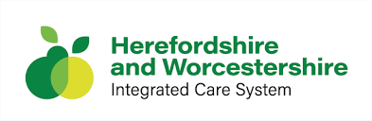

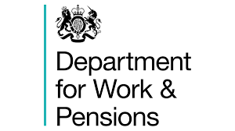



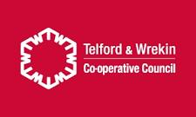

September 2025

Contents
1. Introduction 1
1.1 The Get Marches Working Plan 1
2. Strategic Policy Context 2
2.1 Get Marches Working Objectives 3
3. Theory of Change & Governance 4
3.1 The Get Marches Working Plan Vision 4
3.2 Get Marches Working Theory of Change 5
3.3 Proposed Governance Structure 7
3.4 Stakeholder Network 8
3.4.1 Current Network 8
3.4.2 Stakeholder Evolution 9
4. Labour Market Analysis – Marches Region 10
4.1 Headline Labour Market Challenges 11
4.1.1 Economic Inactivity in The Marches 11
5. Get Marches Working – Strategic Target Groups 16
5.1 Introduction 16
5.2 Group A: Disadvantaged Young People 16
5.3 Group B: Disabled Adults 29
5.4 Group C: People with a Health Condition 33
5.5 Sub Group 3 - Chronic Conditions (e.g. MS, ME, Long Covid, COPD) 39
5.7 Group D: People with Caring Responsibilities 42
Appendix A Strategic Policy Review 51

Introduction

The Get Marches Working Plan
The UK is the only major economy that has seen its employment rate fall over the last five years, reversing the previous long-run trend of declining rates of economic inactivity. This has been driven predominantly by a rise in the number of people out of work due to long-term ill health.
The local Get Britain Working plans form a central component of the UK Government’s wider employment strategy, designed to address both the supply and demand challenges within local labour markets. In particular the goal is to boost the employment rate.
% of the working age population in employment in G7 countries 2019-2025

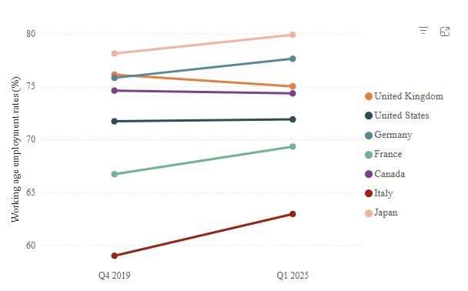
Source: The Learning & Work Institute; ONS

Rooted in the ambitions of the national Get Britain Working White Paper, these plans aim to build a coordinated, whole-system approach that drives up labour market participation, supports job progression, improves earnings, and enhances job quality across diverse communities. Local areas are expected to set clear, outcome-focused goals aligned with national metrics, enabling meaningful and measurable improvements in employment, inclusion, and economic resilience over the next decade.
To deliver on this vision, each area is required to develop a locally owned and collaboratively developed action plan that reflects specific priorities, labour market challenges, and the current landscape of support available for individuals and employers.
Plans should set out robust governance arrangements, demonstrate active engagement with a wide range of stakeholders, and identify clear short-, medium-, and long-term objectives. This includes analysing economic inactivity data, mapping existing provision, identifying service gaps and duplication, and setting out practical steps to strengthen coordination across partners.
While local capacity may vary, all areas are encouraged to take a phased approach—prioritising the foundations for integrated delivery and continuous improvement over time.
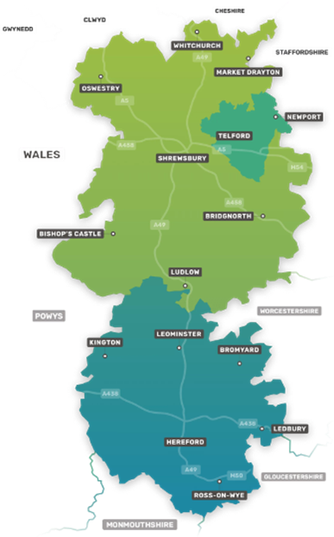
The Get Marches Working (GMW) Plan is the localised version of the strategy that has been produced to cover the local authority areas of Herefordshire, Shropshire and Telford & Wrekin. This GBW area is coterminous with the former Marches LEP area and the extant Connect to Work delivery area.
The GMW Plan analyses key data relating to economic inactivity and presents a view of existing activity delivered by local partners and identified gaps in available support to enable people to become economically active and participate in the local labour market. The Plan is designed to help and guide partners collaboration across the Marches geography and to help steer changes to activity where partners consider this would improve effectiveness and efficiency. However, there is a recognition by partners that filling many of these gaps is not possible without additional resources and financial support.

Strategic Policy Context
A Marches region strategic policy review provided a structured assessment of the existing policy landscape across the three constituent authorities of the Marches GBW region. This helped to highlight those areas of content within each policy document which aligned with the outputs/outcomes of the Get Britain Working Plan.
By drawing on this available evidence, this review has helped to support the informed development of the GMW Plan as well as helping to shape its future direction, ensuring that the Plan remains responsive, outcomes-focused, and aligned with long-term strategic goals of the Get Britain Working Plan.
Set out below are the list of policy documents which were included with this strategic policy review:
- Herefordshire Council Corporate Plan 2024-28.
- Economic Development Strategy for Herefordshire.
- Herefordshire Education Strategy 2024-2029.
- Herefordshire’s SEND Strategy (2023–2026).
- Herefordshire’s Health and Wellbeing Strategy (2023–2033).
- The Shropshire Plan 2022-2025.
- Shropshire Economic Growth Strategy 2022-2027.
- Shropshire Employment & Skills Strategy.
- The Shropshire Youth Strategy.
- The Shropshire Joint Health and Wellbeing Strategy (2022–2027).
- The Shropshire SEND Strategy.
- Telford Council Plan 2022-2026.
- Invest Telford – Our Vision for Fair and Inclusive Economic Growth.
- The Telford & Wrekin Skills Strategy.
- Telford & Wrekin’s SEND & Alternative Provision Strategy (2023–2028).
- Telford & Wrekin’s Health & Wellbeing Strategy (2023–2028).
- Herefordshire & Worcestershire ICB - WorkWell Pilot.
- Herefordshire & Worcestershire ICB - Health and Work Strategy (2025-2030)
- Marches Region - Local Skills Improvement Plan (LSIP).
- Connect to Work (Marches Region).

Please refer to Annex A for the complete strategic policy review.

Get Marches Working Objectives
Analysis of the policy documents listed above, their alignment with the Get Britain Working White Paper and our analysis of key labour market issues that influence economic activity delivers a set of seven common objectives for the GMW Plan:
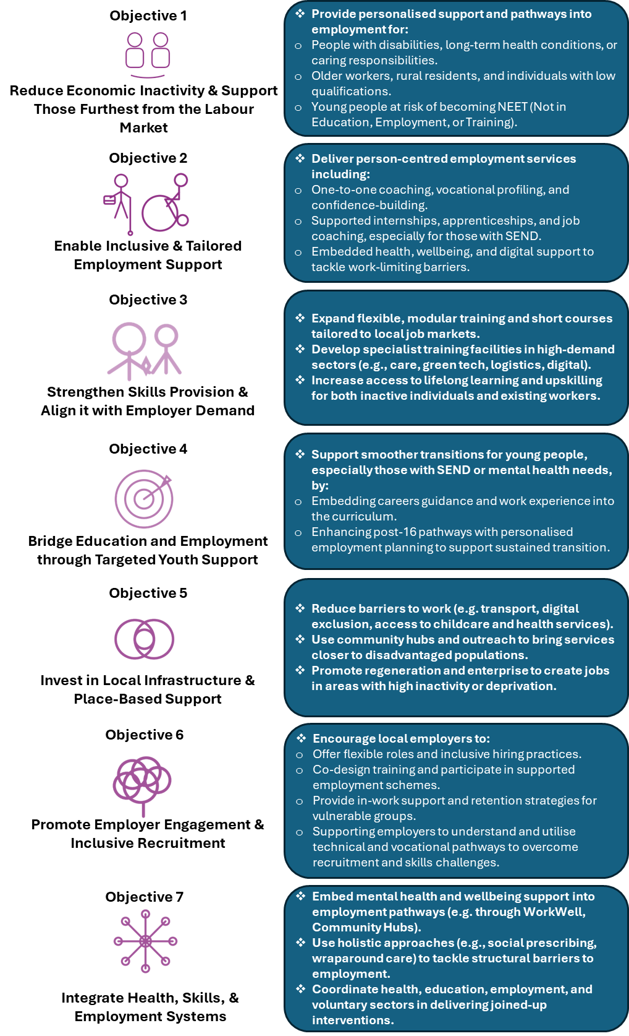

Theory of Change & Governance

The Get Marches Working Plan Vision
“Reducing economic inactivity across the Marches by creating an inclusive, integrated system of employment, skills, and health support that empowers people to overcome barriers and thrive in sustainable work.”
The GMW Plan sets out a bold and collaborative vision for how the area can strengthen its labour market, improve skills pathways, and connect more people with sustainable employment. The Marches – spanning Herefordshire, Shropshire, and Telford & Wrekin – has a diverse economy and workforce needs, and meeting these effectively requires a joined-up approach that maximises the strengths of partners across sectors.
Central to the plan is the ambition to deliver far greater strategic partnership working across the region. By bringing together local authorities, employers, education and training providers, Jobcentre Plus, Integrated Care Boards, voluntary and community organisations, and wider stakeholders, the plan provides a shared framework for aligning priorities and pooling resources. This will not only reduce duplication of effort but also ensure that interventions are better targeted, more coherent, and more impactful for individuals and employers alike, maximising opportunities.
The plan also establishes a mechanism for stronger strategic oversight of services across the Marches. This oversight allows partners to identify gaps in provision, recognise areas of overlap, and build on existing good practice. By mapping services and interventions, the plan highlights opportunities to connect programmes more effectively, develop joint delivery models, and ensure services are designed around the needs of people rather than the structures of organisations.
Equally important, the plan provides a platform to identify synergies and opportunities for partnership working. For example, aligning employer-led initiatives with training provision, strengthening links between schools and businesses, and embedding employability support within community services can unlock new pathways into work. This collaborative approach will also enable the Marches to respond more quickly and flexibly to changing labour market conditions, ensuring that people, businesses and communities remain resilient in the face of economic challenges.
By fostering this culture of partnership and shared oversight, the GMW Plan creates the conditions for a more inclusive and dynamic labour market. It ensures that the region not only addresses current employment and skills challenges but also positions itself strongly for future growth, innovation, and prosperity.

Get Marches Working Theory of Change
The GMW Plan sets out a clear framework for reducing economic inactivity and supporting people into sustainable employment. The Theory of Change begins with an acknowledgement of the differing starting points across the three districts of the Marches and among the delivery partners involved in supporting people’s economic participation.
Although these variations are not shown in detail on the diagram, they underpin the logic of change that follows. Building on this shared understanding, the Theory of Change identifies the key labour market challenges facing the Marches – including high levels of economic inactivity, low earnings, and limited progression opportunities – and aligns with the broader ambition of the Get Britain Working White Paper: to raise the UK employment rate to 80% while improving outcomes for individuals and employers.
The Plan is built around seven strategic priorities, from reducing economic inactivity and enabling inclusive employment support, through to strengthening skills provision, promoting employer engagement, and integrating health, skills, and employment systems. Together, these priorities create a framework for aligning services to employer demand and ensuring people have the right support at every stage of their journey into work.
Delivery is targeted towards five priority groups who face significant barriers to employment: disadvantaged young people, disabled adults, people with health conditions, those with caring responsibilities, and individuals facing multiple disadvantages. Coordinated support will help these groups to access health and wellbeing services, build confidence, develop skills, and connect with local employment opportunities.
As a result, individuals across the Marches will experience more personalised and inclusive employment support, better access to joined-up health and skills services, and greater opportunities to sustain work and progress in their careers. Employers, in turn, will benefit from a stronger, more diverse workforce and improved support to provide inclusive employment opportunities.
Ultimately, the outcomes will be transformative: economic inactivity across the Marches will fall well below the national average by 2030, and employment, skills, and health services will operate as a coordinated and effective system. This will deliver not only improved employment outcomes but also long-term prosperity and resilience for the region.

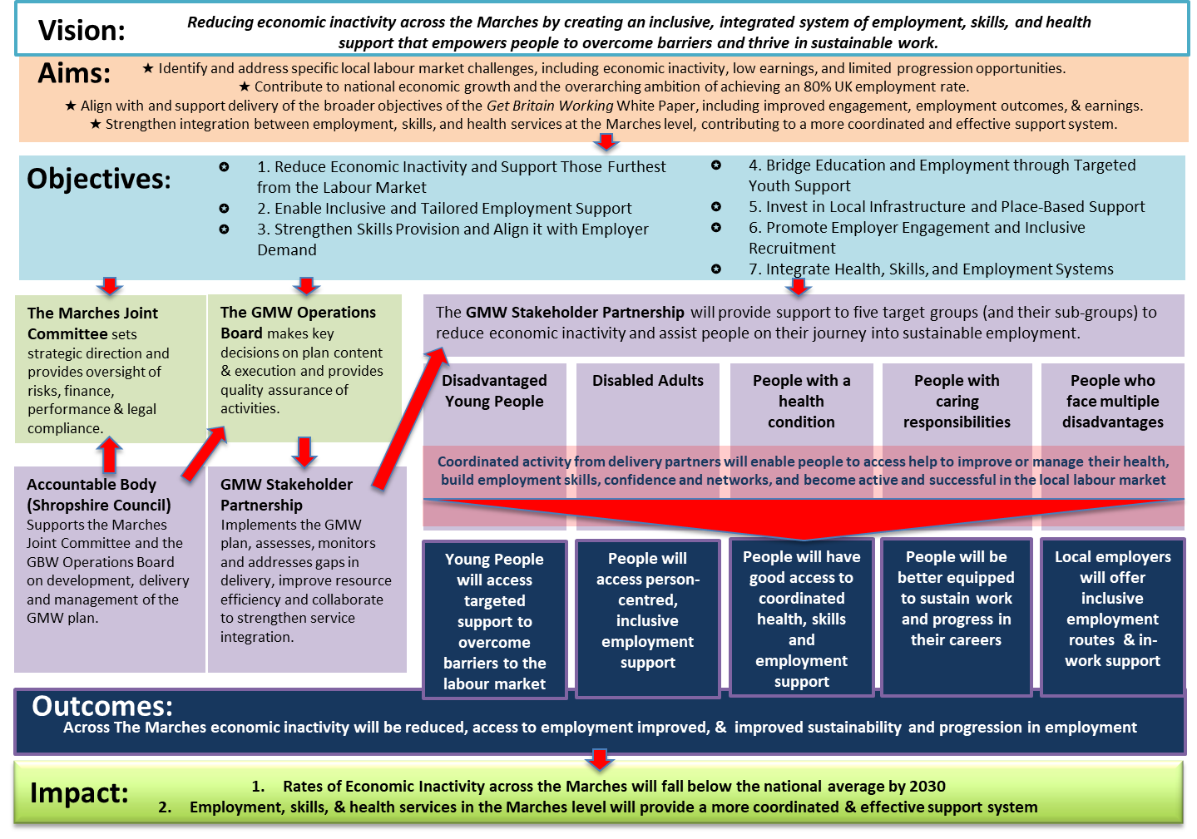

Proposed Governance Structure
At the heart of the plan is a structure of strong governance and partnership. The Marches Joint Committee provides strategic direction and oversight, while the GBW Operations Board ensures quality assurance and effective implementation. The GBW Stakeholder Partnership, supported by the Accountable Body, brings together partners to deliver the plan, monitor performance, and strengthen service integration. This collective approach allows the region to identify gaps in provision, reduce duplication, and seize opportunities for joint delivery.
A detailed breakdown of the Governance structure is set out below:
Marches Joint Committee
Committee details - https://shropshire.gov.uk/committee-services/mgCommitteeDetails.aspx?ID=804#
Membership:
- Executive Directors - Herefordshire, Shropshire and Telford and Wrekin.
- Cabinet member/Leader - Herefordshire, Shropshire and Telford and Wrekin.
Frequency of meetings: Quarterly.
Role:
- Strategic Oversight: The Board sets the overall direction and strategy for the GMW Plan, ensuring it aligns with the organisation’s mission and goals.
- Governance: They establish policies and procedures to ensure the Plan operates effectively and ethically, maintaining transparency and accountability.
- Financial Management: The Board oversees the budget, approves funding allocations, and ensures financial resources are used efficiently and responsibly.
- Risk Management: They identify potential risks and develop strategies to mitigate them, ensuring the Plan’s sustainability and resilience.
- Performance Monitoring: The Board regularly reviews the Plan actions performance, assessing whether they meet their objectives and making adjustments as needed.
- Compliance: Ensuring the Plan adheres to all relevant laws, regulations, and ethical standards is a critical role of the board.
Responsibilities:
- Approve strategic plans and budgets as per the terms set out in the national Get Britain Working Plan.
- Monitor Plan performance and outcomes against local strategies and growth plans.
- Ensure compliance with legal and ethical standards.
- Engage in fundraising and resource development.
Operations Board
Members:
- Project Lead – Accountable Body (Shropshire County Council).
- Local Authority Skills representatives.
- Employer representee.
- Voluntary Community Sector.
- Jobcentre Plus.
- Integrated Care Board.
- Education (FE and HE).
Frequency of meetings: Monthly in development stages – Annually in review and monitoring stages.
Purpose: The Get Britain Working Operations Group is established to develop, monitor, and review the GMW Plan for Shropshire, Telford and Wrekin, and Herefordshire. The group aims to develop a plan that enhances employment opportunities, supports local businesses, and ensures a coordinated approach to workforce development.
Role:
Chairperson: To lead meetings and ensure effective communication among members.
Facilitator: To set agendas, record minutes, manage documentation, and coordinate meeting logistics.
Members: To actively participate in meetings, contribute to discussions, and support the implementation of the GMW Plan.
Objectives:
- Monitor the implementation of the plan and ensure it aligns with local and national employment strategies.
- Review and update the plan regularly to reflect changing economic conditions and workforce needs.
- Foster collaboration among local authorities, Jobcentre Plus, Integrated Care Boards (ICB), Voluntary and Community Sector (VCS), and employer representatives.
- Identify and address barriers to employment and skills development in the region.
- Promote inclusive employment practices and support disadvantaged groups in accessing job opportunities.
Decision Making: Approve key plan execution decisions, including major adjustments, budget revisions, and auditing. Make management decisions by consensus when required.
Quality Assurance: Ensure the quality of the plans development and monitoring by reviewing progress. Take corrective actions as needed to achieve the desired results.

Stakeholder Network

Current Network
To date, a range of engagement activities have been undertaken to support the development and implementation of our local plan under the Get Britain Working strategy. These activities have focused on ensuring inclusive participation, gathering meaningful feedback, and aligning local priorities with national employment goals.
Key engagement efforts include:
- Stakeholder Consultations/Get Britain Working Operations Board: We have held regular meetings with local employers, colleges and training providers, Jobcentre Plus representatives, Public Health and voluntary and community organisations along with local Integrated Care Boards to identify skills gaps and employment barriers specific to our area.
- All Local Authority Skills Groups are represented on the Get Britain Working Board, ensuring a two-way flow of communication. This structure enables each group to contribute to, and be informed by, the development of the plan.
- Business Boards: To engage with employers directly to gain insight into the barriers to recruitment, HR challenges and opportunities.
- Careers Enterprise Company: Their engagement ensures our local plan is aligned with national best practices in careers education and employer engagement. The CEC’s expertise in connecting schools, colleges, and employers is invaluable in helping us design effective pathways for young people into the workforce. By collaborating with the CEC, we can better understand local labour market needs, enhance the quality of careers guidance, and strengthen our approach to skills development.
- Youth Engagement Initiatives: Collaboration with schools, colleges, and youth organisations has helped us to understand the aspirations and challenges faced by young people entering the workforce. This has informed our approach to apprenticeships and vocational training. This has been done through the CEC, skills groups, education and employer groups.
- Online Surveys and Feedback Tools: Digital platforms are being used to gather input from a wider audience, enabling us to reach individuals who may not attend in-person events. This feedback has been instrumental in refining our local plan priorities.
- Education and Employer Groups: Provide a medium through which we can ensure the input of real-world insights from both the education sector and the business community. This collaboration enables us to bridge the gap between education and employment by aligning curriculum development with current and future labour market needs. Engaging with this group helps us identify opportunities for work-based learning, apprenticeships, and employer-led training initiatives, ensuring that young people and adults are equipped with the skills and experiences needed to thrive in the local economy. Their input is vital in shaping a responsive and inclusive employment strategy.

Stakeholder Evolution
As we move from the design to the implementation stage of the GMW Plan, the lead authority is committed to ongoing engagement with a broad range of stakeholders to ensure the strategy remains inclusive, evidence-based, reflective of local needs and promotes a fully integrated approach to commissioning across and between services and geographies.
Externally, engagement will continue with the voluntary and community sector through the VCS representative bodies operating in each of the three constituent Marches authorities: the Shropshire Voluntary and Community Sector Assembly, Telford & Wrekin Council for Voluntary Service and the Herefordshire Voluntary Organisations Support Service, recognising the vital role these organisations play in supporting individuals furthest from the labour market.
There will also be regular consultation with the respective Skills Boards, the Herefordshire Business Board, the Chambers of Commerce and local Growth Hubs to ensure that the Plan continues to align with changing local economic priorities and employer needs. This input will be supplemented by that garnered directly from employers who may be asked to participate in the Board’s deliberations on an ad-hoc basis (as well as providing additional ongoing scrutiny of local authority economic development activities which themselves will serve to facilitate local employment growth via business expansion and new inward investment). These consultations will continue to evolve throughout the duration of the Plan. Post 16 education & training providers, UKSPF delivery partners and community health providers are also key participants in this consultation activity.
The engagement and participation of the two ICB organisations covering the Marches area as the Plan continues to evolve will also be fundamental to ensuring that future planning and commissioning of all health-related services is undertaken in alignment with and embedded within the strategic context of the Marches wide delivery plan approach.
Internally, we will continue to work closely with key departments and teams across the three councils, including Public Health, Economic Development, Care Leavers Services, the Youth Employment services (e.g. Youth Employment Hub – Herefordshire, Youth Support Trust – Shropshire and SYA Shropshire and Telford & Wrekin), Community Wellbeing, and Talk Community Teams (Shropshire and Telford & Wrekin). In addition to this, we will ensure that elected members (both at the unitary and parish tiers) are engaged fully throughout this process.
This cross-departmental collaboration will ensure that our approach is holistic, addressing the wider determinants of employment and supporting residents through an integrated service approach.

Labour Market Analysis – Marches Region
A robust analysis of local labour market dynamics is essential to ensure that interventions are evidence-based, targeted, and aligned with both local priorities and the wider objectives of the GMW Plan.
By examining economic inactivity rates, the geographic pattern of unemployment and the qualification levels and health of the economically inactive, this section provides the evidence base to allow for the targeting of coordinated actions which can help reduce inactivity, strengthen progression pathways, and create a more inclusive labour market—ensuring the Marches is able to deliver against the objectives set out in the Plan.

Headline Labour Market Challenges

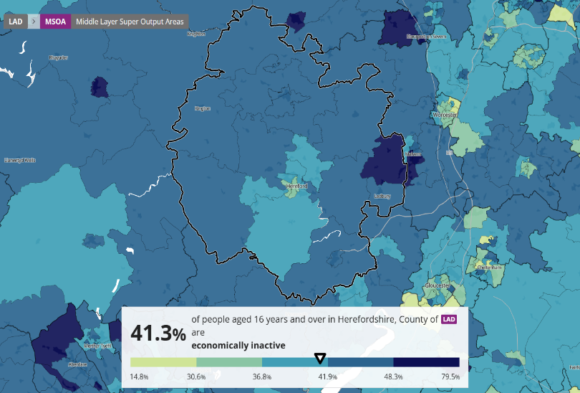
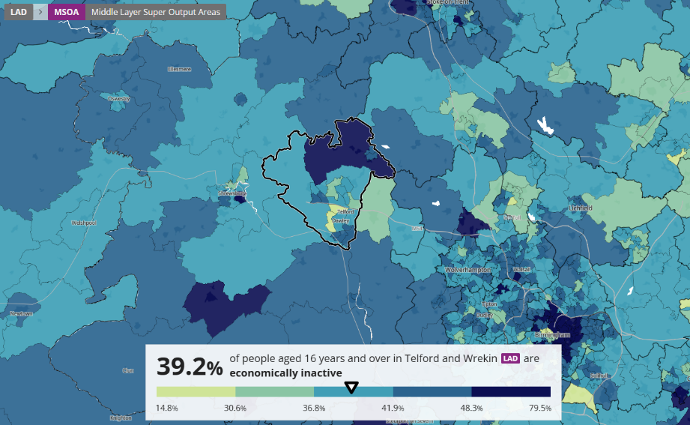
Economic Inactivity in The Marches
Herefordshire
Economic inactivity is not spread evenly across the Marches area. It is slightly lower in Telford & Wrekin – perhaps a reflection of the younger demographic profile in the district. However, Shropshire, Herefordshire and Telford & Wrekin all have pockets of very high inactivity, and large (mainly rural) areas where inactivity is relatively high.
Shropshire
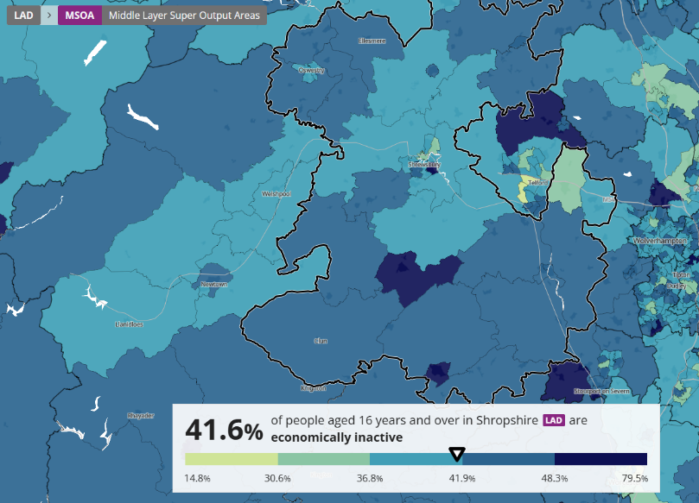
The geographic spread does not tell the whole story. Herefordshire and Shropshire have relatively high rates of retired people who are inactive, whereas Telford has higher proportions of carers and long-term sick or disabled

Telford & Wrekin

Source: ONS, Census 2021

.
Economic Inactivity in The Marches
 | Herefordshire |  | Shropshire |  | Telford & Wrekin |  | The Marches
Economically inactive: Looking after home or family | 5,836 | 3.7% | 9,814 | 3.6% | 7,460 | 5.0% | 23,110 | 4.0%
Economically inactive: Long-term sick or disabled | 5,614 | 3.6% | 9,574 | 3.5% | 7,886 | 5.3% | 23,074 | 4.0%
Economically inactive: Other | 3,867 | 2.5% | 6,707 | 2.5% | 4,317 | 2.9% | 14,891 | 2.6%
Economically inactive: Retired | 44,635 | 28.4% | 77,553 | 28.5% | 31,490 | 21.2% | 153,678 | 26.6%
Economically inactive: Student | 5,017 | 3.2% | 9,687 | 3.6% | 7,137 | 4.8% | 21,841 | 3.8%
Total economically inactive | 64,969 | 41.3% | 113,335 | 41.6% | 58,290 | 39.2% | 236,594 | 40.9%
%Total population: Residents aged 16 years and over | 157,132 | 100% | 272,245 | 100% | 148,670 | 100% | 578,047 | 100.00
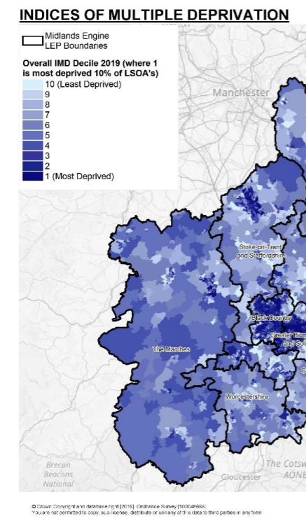
Source: Census 2021
The Index of Multiple Deprivation reveals a pattern of large rural areas with high deprivation and some areas of very high deprivation in the larger urban settlements, e.g. Shrewsbury, Ludlow and Telford. These run alongside areas of relatively lower deprivation.

Source: ONS, IMD 2019
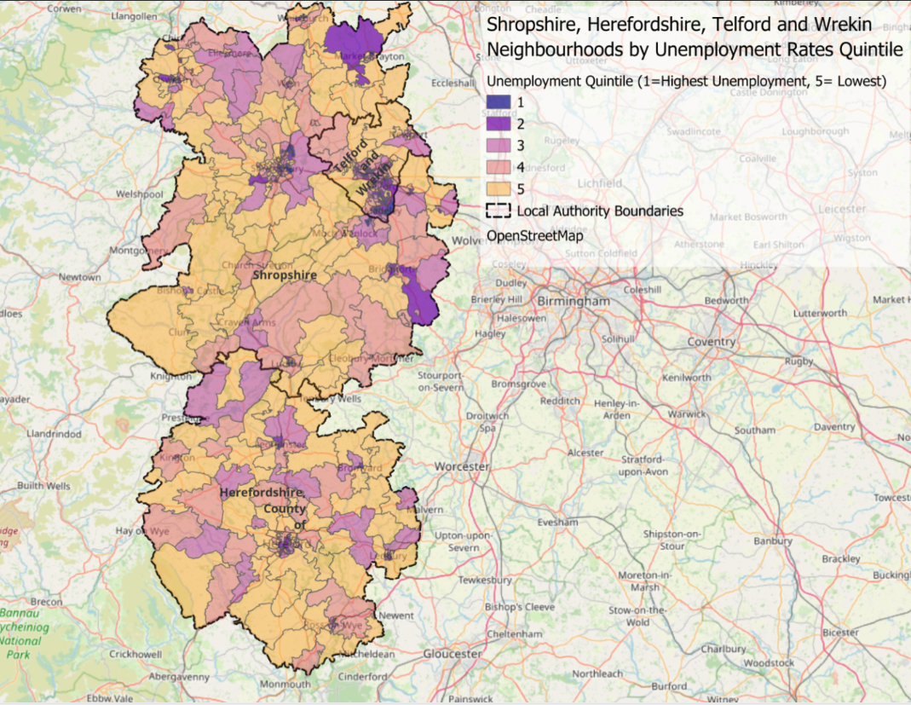
The geographic pattern of unemployment follows a similar pattern of both rural and urban clusters where it is above average. This is shown in the following graphic.
Source: ONS, Nomis Claimant Count, 2025
Skills & Employment Issues
Economic Activity Status Reasons by Highest Level of Qualification
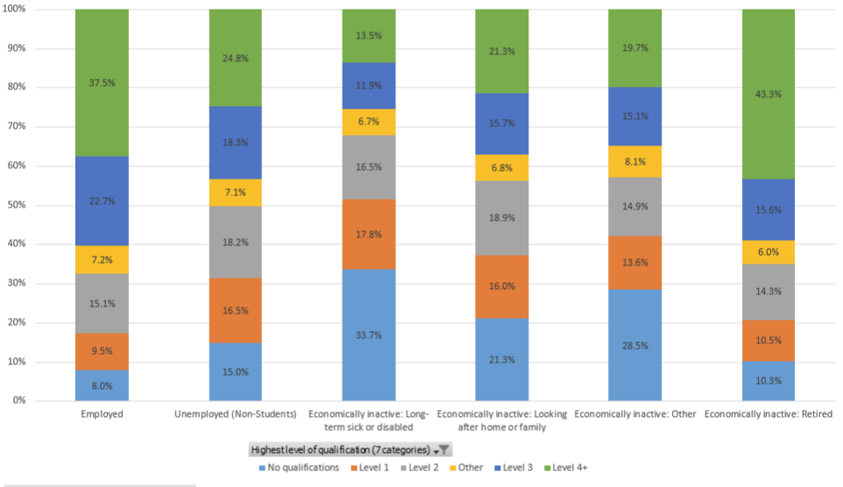

Source: Census 2021

The skills profiles of those unemployed and inactive are lower than those within the employed workforce, making upskilling a priority action.
Encouraging those inactive who have retired back into work would bring significant skills back into the local Marches workforce.

Former Economic Sector of Employment of those unemployed
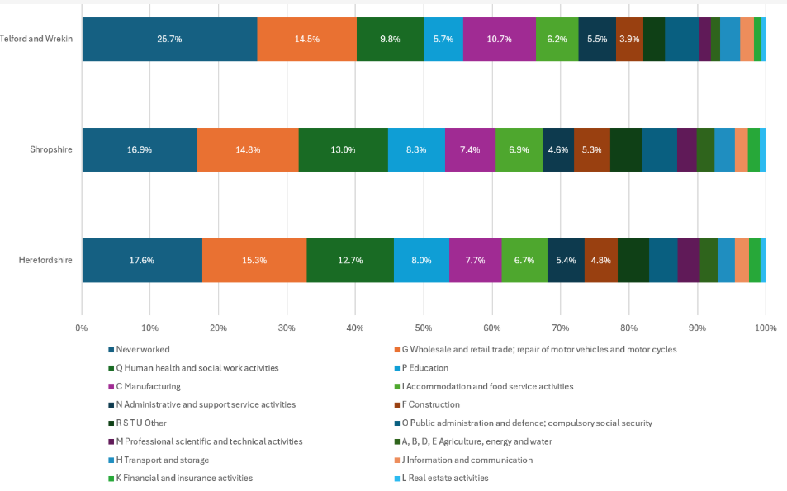

Source: Census 2021

There are sectors with higher proportions of people who have experience of working within them, but there is also a reasonable spread across most sectors. This indicates a nuanced approach to create employment pathways is required, one that:
- Helps people find work where they have experience
- Or helps them shift to new work they can do, particularly those with existing or emerging health issues.
Initiatives need to include Job matching (through flexible supported employment programme); Job carving, SWAP-style courses (sector based); other targeted interventions.

Health Issues
Economic Activity and Health in The Marches

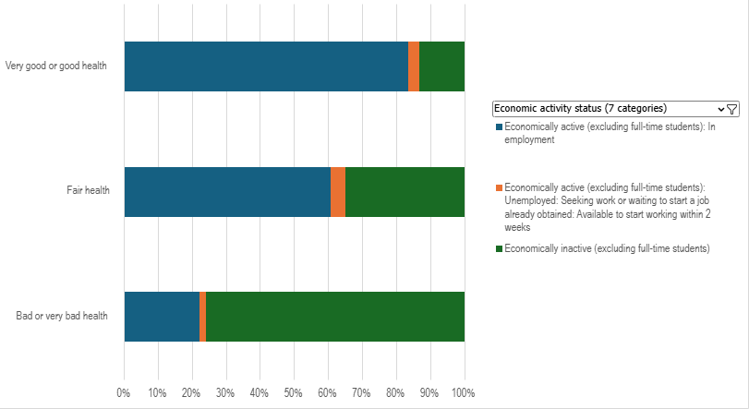
Source: Census 2021

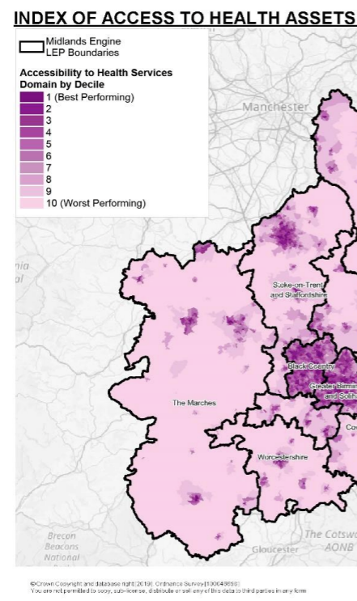
Health level clearly affects propensity to work, but not necessarily for all in the Marches. Almost a quarter of people with bad or very bad health are in work. Therefore, changing perceptions and assisting people with poor or declining health to seek, obtain and sustain employment is important and very possible.
Access to health services outside the urban areas of The Marches is very poor. This relates to access to GPs, hospitals, pharmacies, dentists and leisure services (and is in no way a reflection on the quality of individual health providers in these areas). Given the rural /urban patterns of inactivity and unemployment this may present a challenge in terms of creating employability pathways for those with health issues who live in rural areas; and, supporting those in-work suffering declining health.

Source: Midland Engine

Get Marches Working – Strategic Target Groups

Introduction
This section draws in the broad labour market analysis of Section 4 and builds the evidential basis for the priority target groups within the Marches. Analysis blends national and local data to identify the issues pertinent to each group and aims to provide a sense of the scale of these in the Marches. Using this analysis, the section goes on to identify the types of interventions that are effective in supporting each group, the current response in The Marches and the gaps that The GMW Plan, and ultimately stakeholders, need to address to deliver outcomes and impact against the GMW aims and objectives.

Data Sources
All data presented below has been derived from recognised national sources (e.g. ONS, Nomis, Labour Force Survey) and information recorded by the constituent local authority areas. Every effort has been taken to ensure the accuracy and comprehensiveness of the cited data. Where there are gaps in the national or local level data this has been acknowledged.
It is recommended that one of the actions for all stakeholders going forward is to review data availability and make improvements to their own data gathering processes where it would add value to the delivery of the Plan e.g. Not in Education Employment or Training (NEET).
Priority Groups
- Disadvantaged Young People aged 16 up to 25
  - NEET
  - Care Leavers
  - Special Educational Needs and Disabilities /Learning Difficulties & Disabilities
  - Physical Disability
- Disabled Adults
- People with a Health Condition
  - Musculoskeletal (MSK) & Physical Disability
  - Mental Health & Severe Conditions
  - Chronic Conditions (e.g. MS, ME, Long Covid, COPD)
- People with Caring Responsibilities
  - Lone Parent Households
  - Young Carers & Parent-Carers

Group A: Disadvantaged Young People aged 16 up to 25
In Herefordshire, Shropshire, and Telford & Wrekin several groups of young people face distinct challenges in accessing education, employment, and training. Young people who are NEET represent a key area of concern.
Care leavers represent one of the most vulnerable groups, facing barriers to education, employment, and housing. Local authorities have published pledges and support frameworks for care-experienced young people, though detailed local statistics are not always publicly available.
Young people with Special Educational Needs and Disabilities (SEND) also require tailored educational support. While school place allocation in 2024 was high—nearly 98% of children in Herefordshire, over 95% in Telford & Wrekin and nearly 98.4% in Shropshire received one of their preferred secondary school places—placement alone does not ensure that the needs of SEND learners are fully met.
Disability, as defined by the Equality Act 2010, includes conditions with a substantial and long-term impact on daily life. For some young people, this can present additional barriers to education and employment. Enhanced data collection and targeted service provision can help improve outcomes for these groups across the region.
It is acknowledged that individuals may face several challenges/barriers to work which cut across many groups outlined below. In such circumstances there may be a need for an individual to draw on a suite of interventions from those listed under multiple different sub-groups. This plan does not seek to preclude the possibility of taking such multi-faceted approach.

Subgroup 1 – NEET aged 16-24
NEET refers to young people (typically aged 16-24) who are not currently in education, employment, or training. There will be a number of reasons these young people are not participating, including individual circumstances such as illness, lack of qualifications/work experience, caring responsibilities, low aspirations and motivation, family circumstances etc.
National Context:
Nationally, approximately 13.4% of 16–24-year-olds were reported as NEET by the end of 2024, an increase of 1.3 percentage points from the previous year.
The Youth Futures Foundation commissioned the National Centre for Social Research to explore risk factors for being NEET among young people. The two charts highlight the nature of the 19 risk factors identified and rates among young people, and the impact of possessing an increasing number of these factors on the likelihood of becoming NEET. There is a clear statistical correlation between the prevalence of NEET status and an increasing number of risk factors highlighting the complex and difficult nature of progressing these young people into employment.

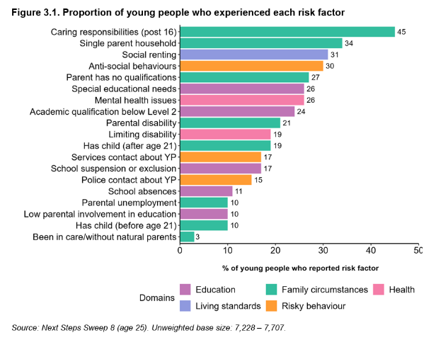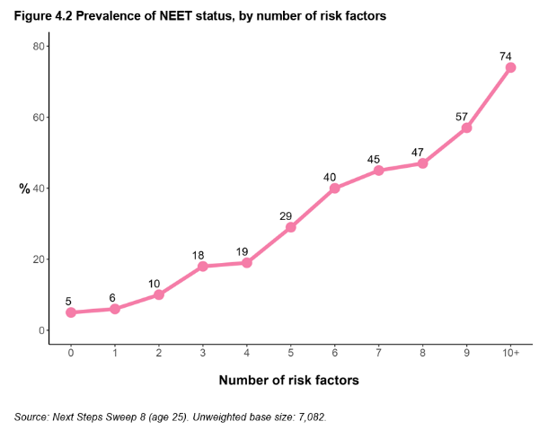

- In the 3 years from 2017 to 2019, an average of 11.5% of young people aged 16 to 24 in the UK were NEET.
- Young people were more likely to be NEET and economically inactive (6.9%) than NEET and unemployed (4.6%) – the figures for White young people were similar to the UK average, at 7.0% and 4.6%.
- Young people in the Chinese (4.5%) and Indian (7.3%) ethnic groups were less likely than the UK average to be NEET.
- Young people in the Pakistani ethnic group were more likely to be NEET (14.3%) than those in the Chinese and Indian ethnic groups.
- Among White young people, females were more likely to be NEET and economically inactive (8.6%) than males (5.6%) – but males were more likely to be NEET and unemployed (5.5%) than females (3.7%).
The Marches Context
- In Herefordshire the proportion of the 16-17 cohort which are NEET is 5.2% (2025). 1.6% increase from previous year and the highest rate since 2020. Shropshire saw a small decline in its NEET population in 2025, which now stands at 2.6% (a reduction of 0.1% on the previous year). This is however still a higher figure than during the 2020-2023 period.
- By comparison, Telford & Wrekin saw an increase of just 0.3% from 2024 to 4% in 2025. Third highest rate since 2020
- Both Herefordshire and Telford and Wrekin are above England average of 3.4%
- Claimant count in the Marches area for 16- to 24-year-olds is 5.4% (2575) and has been increasing month on month and is now the highest it has been since October 2021. The highest number of claimants is in Telford and Wrekin 7.5% (1115). Shropshire 4.2% (905) and Herefordshire 4.7% (550)
GMW Analysis
- Those who are NEET are not a homogenous group. There are multiple causes a young person may become isolated from education, employment, or training. Risk factors rooted in experiences of adversity are a unifying feature amongst NEET young people. These include disengagement from education, exclusion, deprivation and poverty, mental health, SEND needs without adequate support, family circumstances, and prior exposure to crime and violence. This isn’t an exhaustive list, and the Marches are aware of other factors that may contribute to a young person becoming NEET.
- Experiencing any of these risk factors in childhood and early adulthood can have negative impacts on young people, causing a cycle of disadvantage which, in some cases, permanently excludes them from the labour market, or causes lifetime ‘wage-scarring’ for those who enter employment, and increases chances of engaging in violence/crime.

Subgroup 2 – Care Leavers
Care leavers are young people aged 16-25 years old who have been in care at some point since they were 14-years old and were in care on or after their sixteenth birthday.
National Context
- In 2024, the number of children looked after (CLA) by local authorities in England was 83,630, representing a rate of 70 per 10,000 children. These trends are notably influenced by a growing cohort of unaccompanied asylum-seeking children (UASC), who are typically older (aged 16+), male, and remain in care for shorter periods.
- Care leavers in England aged 19-21 have a significantly higher rate of not being in education, employment, or training.
- 39% of care leavers in this age range are NEET, while only 13% of all young people aged 19-21 are NEET. This suggests that care leavers face greater challenges in securing education, training, and employment.

The Marches Context
- In Herefordshire, looked-after children rose from 270 in 2015 to 412 in 2023. The 2021 count of care leavers aged 16–24 was 298, with NEET rates around 48–55%. Ofsted rated services “Inadequate” in 2022. The county has some of the highest rates of children in care and child protection activity, when compared to statistical neighbours, alongside severe budget pressures and costly placements.
- In Shropshire, the number of looked-after children rose sharply from 399 in 2020 to around 656 by March 2023. In 2021, there were 369 care leavers aged 16–24, with NEET rates peaking at 49% in 2020 and averaging around 40%. Shropshire Council Children’s services were awarded an overall Ofsted rating of Outstanding in 2025.
- Telford & Wrekin saw an increase in looked-after children from 403 in 2020 to 453 in 2023. There were 259 care leavers in 2021, with NEET rates fluctuating between 37% and 48%. Telford and Council Children’s services were awarded an overall Ofsted rating of Outstanding in 2024. The council has declared care experience a protected characteristic and adopted the Care Leaver Covenant.
GMW Needs Analysis
- Care leavers face a range of challenges when entering the workforce. Many have limited work experience and lower educational attainment due to disrupted schooling, leaving them underprepared for employment. Emotional and mental health difficulties – such as low confidence and the impact of past trauma – further effect their ability to engage with work. Financial insecurity and unstable housing often create practical barriers to job-seeking and sustaining work. Without strong support networks, they also lack the informal guidance and connections that help many young people find jobs. Unaccompanied asylum-seeking children (UASC) face additional obstacles, including language barriers, immigration issues, and cultural differences. Employers’ lack of understanding as to the additional barriers that care leavers face and the additional support they can require can mean early negative employment experiences impacting upon a willingness to take up other opportunities.

Subgroup 3 – Special Educational Needs and Disabilities/Learning Difficulties & Disabilities
There is some overlap across those with Special Educational Needs and young people with Learning Difficulties & Disabilities, due to data recording. Separate data is presented for each group however the needs analysis for these groups is almost identical. Further local analysis is required to define needs across the Marches to guide policy responses that are required.
A young person with SEND is defined as someone who has a learning difficulty or disability that requires additional or different support to access education and health support effectively. Support is needed because the individual finds learning significantly more difficult than most others their age or has a disability that makes it challenging to access mainstream education without specialist assistance or equipment.
National Context:
- There are more than 900,000 people with SEND and learning difficulties or disabilities who are of working age, yet research shows that just 5% are in employment. This is despite 86% of people with learning disabilities wanting to work (mencap).
- There are 1,673,205 pupils in England identified as having SEND, which represents 18.4% of the total pupil population, according to the Association of School and College Leaders (ASCL). This highlights that nearly one in five pupils in England requires some form of additional support in their education.
- Out of the total number of pupils with SEND, 434,354 have an Education, Health and Care Plan (EHCP), accounting for 4.8% of all pupils (2024). Early data for 2025 shows this figure reaching 5.3%. EHCPs are designed for children and young people with the most complex needs, providing legal entitlement to support across education, health, and social care settings.
- A further 1,238,851 pupils receive SEN support without an EHCP, making up 13.6% of all pupils. These students require additional assistance within mainstream education settings, but their needs are not assessed as requiring an EHCP.
Marches Context:
The number of young people
The percentage of young people with an Education Heath and Care Plan (EHCP) recorded as continuing into sustained education, employment or apprenticeship after completing year 11 in 2022 was 88.9% Herefordshire, 88.3% Shropshire and 74.8% Telford and is above the percentage of young people with SEN support. This is with the exception of Telford, which is below (Herefordshire 86.8%, Shropshire 87.3%, Telford 86.7%) but below the percentage of young people with no SEN support (Herefordshire 92.8%, Shropshire 92.5%, Telford 95.25%).
Percentage of young people SEN aged 16 and 17 recorded as in Education and Training 2025
All areas are above the England average in 2025 except for Herefordshire which is below and saw a 1.94% decrease from 2024 against national increase of 0.30%
Herefordshire | Shropshire | Telford and Wrekin | West Midlands | England
82.16% | 93.41% | 87.84% | 88% | 87.4%
Attainment of Level 2 at age 19 in 2024
% of 19-year-olds qualified to level 2 with SEN Support
Herefordshire | %change from 2023 | Shropshire | %change from 2023 | Telford and Wrekin | %change from 2023 | England | %change from 2023
74.54% | 3.34% | 62.66% | -6.32% | 68.32% | -5.08% | 64.86% | -1.45%
% of 19-year-olds qualified to level 2 including English and Maths with SEN Support
Herefordshire | %change from 2023 | Shropshire | %change from 2023 | Telford and Wrekin | %change from 2023 | England | %change from 2023
52.03% | -2.37% | 35.69% | -9.23% | 47.52% | 1.05% | 44.54% | -2.64%
% of 19-year-olds qualified to level 2 with statements/EHCP
Herefordshire | % change from 2023 | Shropshire | % change from 2023 | Telford and Wrekin | % change from 2023 | England | %change from 2023
17.24% | -8.34% | 43.26% | -1.10% | 23.14% | -2.8% | 29.81% | -0.39%
Attainment of Level 2 equates to achievement of 5 or more GCSEs (9-4 or equivalent) or a Level 2 vocational qualification of equivalent size.
Attainment of Level 3 at age 19
% of 19-year-olds qualified to Level 3 with SEN Support
Herefordshire | %Change from 2023 | Shropshire | %change from 2023 | Telford and Wrekin | %change from 2023 | England | %Change from 2023
40.59% | 6.99% | 31.45% | -3.75% | 38.20% | -1.54% | 35.08% | -1.44%
% of 19-year-olds qualified to Level 3 with Statement/EHCP
Herefordshire | %Change from 2023 | Shropshire | %change from 2023 | Telford and Wrekin | %change from 2023 | England | %Change from 2023
8.62% | -5.33% | 19.86% | 4.45% | 12.4% | -0.10% | 14.15% | -0.18%
Attainment at Level 3 equates to achievement of 2 or more A-levels or equivalent size vocational qualifications.
GMW Needs Analysis
- Children and young people with SEND face significant disadvantages from the outset due to an increasingly strained SEND system. Before they reach the stage of seeking employment, many have already experienced unequal access to education compared to their non-SEND peers. This educational disparity puts them at a substantial disadvantage, limiting both their academic progress and future opportunities.
- A lack of adequate preparation for employment or further education leaves many young people with SEND uncertain about their options after school. They are often unable to access helpful, empowering careers advice, are unaware of their rights and available support systems in the workplace and may encounter delays in accessing essential schemes such as Access to Work. This failure to equip SEND young people with the tools they need to transition successfully into adult life perpetuates inequality.
- Delays in diagnosis and barriers to identification further compound these challenges. Many young people wait years for assessments, during which time they may not know whether they are protected under the Equality Act or entitled to reasonable adjustments at work. Without a formal diagnosis, young people may also be unsure what kind of support they need, which increases their hesitancy to request accommodations.
- The transition from childhood to adulthood is marked by a sharp ‘cliff-edge’ in support. As young people with SEND move out of child-focused services, they often lose access to the systems they’ve relied on throughout their lives. This includes disruptions in education, welfare, student finance, health, and social care. These changes are sometimes not well-coordinated, and any lack of streamlined transition support places a heavy burden on young people with SEND and their families.
- Even beyond the transitional period, young people with SEND face systemic and disproportionate barriers to employment. These include workplace discrimination, inaccessible transport and public services, and employers who fail to implement reasonable adjustments.
- To support young people with SEND into work, a multifaceted approach is needed that includes early intervention, individualised support, and partnerships between schools, Further Education (FE), employers, and support services. This involves providing targeted interventions tailored to specific needs, such as improving literacy and numeracy skills, enhancing communication and social skills, and developing vocational skills

Subgroup 4 – Physical Disability
The Equality Act 2010 defines disability as a physical or mental impairment that has a ‘substantial’ and ‘long-term’ negative effect on a person’s ability to do normal daily activities. The Act defines ‘substantial’ as being more than minor or trivial – for example, if it takes much longer than it usually would to complete a daily task like getting dressed. ‘Long-term’ is defined as lasting for a period of 12 months or more – for example, a breathing condition that develops as a result of a lung infection.
National Context
- The UK employment rate for people with physical disabilities remains significantly lower than that for non-disabled individuals, highlighting a persistent and concerning disparity. In 2023, only 53.6% of people with physical disabilities were in employment, compared to 82.5% of non-disabled people. This results in a substantial disability employment gap of 28.9 percentage points, which has remained a consistent feature of the UK labour market despite policy efforts to close it.
- Disabled people are also more likely to be unemployed than their non-disabled peers. In the second quarter of 2023, the unemployment rate for disabled people stood at 7.1%, more than double the 3.5% rate for non-disabled people. This difference reflects not only barriers to entering the labour market but also challenges in retaining employment once gained, particularly for those whose conditions fluctuate or worsen over time.
Marches Context
There is limited data available specifically on young people with a physical disability. However, the population level contextual data can be found below in Section 5.3.
The data above relates to all working age population and includes physical and mental disabilities as per definition. Data is not readily available by specific age group or broken down by Physical and /or mental.

Group B: Disabled Adults
In Herefordshire, Shropshire and Telford & Wrekin, disabled adults, particularly those with learning disabilities or long-term health conditions, face persistent challenges in accessing and sustaining employment.
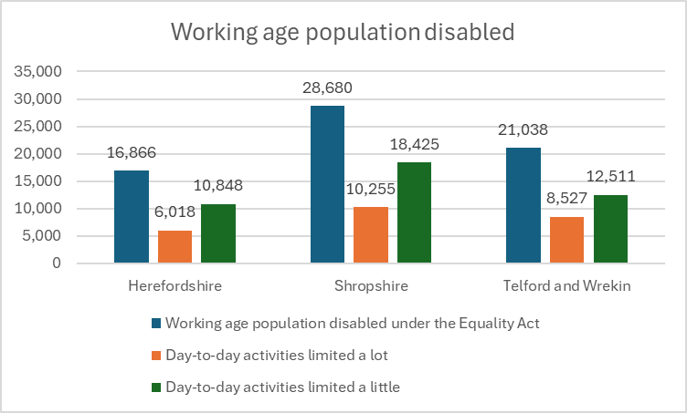
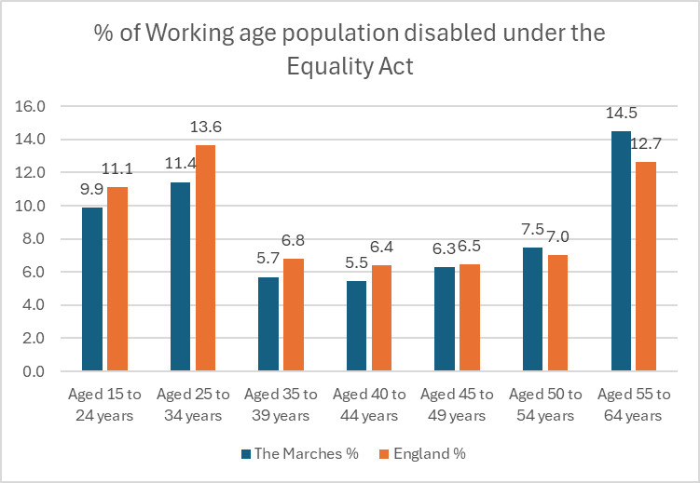

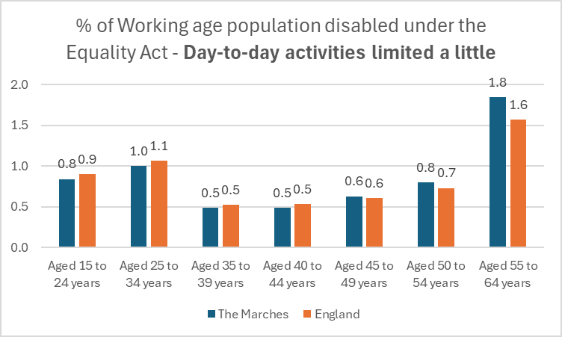
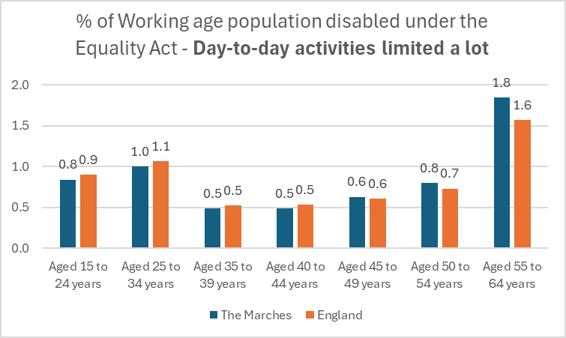

Source: ONS, UK Census 2021
Disability and Employment
Census data from 2021 shows:
- 66,584 people of working age in the Marches are disabled under the Equality Act; this represents 36.3% of the working age population
- 13.5% of the working age population of the Marches have day to day activities are limited a lot and 22.8% have day to day activities limited a little. Those whose day-to-day activities are less limited form the majority of those disabled under the Equalities Act and should be close to the labour market (if not already economically active).
- In terms of age distribution, there are proportionately more people aged 50-65 disabled in The Marches compared to England profile, and consequent lower comparative proportions in younger age groups.
- Compared to national figures (53.6% employment rate and 7.1% unemployment for disabled individuals) local data suggests that while overall adult employment appears robust, disabled adults likely remain underrepresented in work roles in the Marches.
- The employment rate for adults aged 16 to 64 in Herefordshire is 80% (annual population survey January to December 2024) above regional and national average
- 18.4% of people aged 16–64 in Herefordshire are economically inactive (neither employed nor seeking work) according to the latest ONS estimates for the year ending December 2023. This is slightly lower than the West Midlands average but still represents a significant proportion of the working-age population.
- Herefordshire adults of working age were not working due to ill-health or disability than were unemployed and seeking work: 4,900 (4.5%) compared to 3,500 (3.3%). This represented an increase from 3.9% since 2011
- Data from 2021 shows that 6.7% of Herefordshire residents reported being “disabled and limited a lot,” down from 7.8% in 2011 (herefordshire.gov.uk)
- 5% of the residents in Herefordshire self-reported bad/very bad health and 19% self-reported having a disability
- In Shropshire, the overall employment rate for adults aged 16–64 was 78.8% by December 2023, slightly above the West Midlands average. However, 3.5% were economically inactive due to long-term sickness or disability - a rise from 3.0% in 2011 (ons.gov.uk)
- 18.0% of people aged 16–64 in Shropshire are economically inactive (neither employed nor seeking work) according to the latest ONS estimates for the year ending December 2023. This is slightly lower than the West Midlands average but still represents a significant proportion of the working-age population.
- Shropshire Adults of working age were not working due to ill-health or disability than were unemployed and seeking work: 8,800 (4.6%) compared to 5,400 (2.8%). This represented an increase from 3.6% (~6,900 people) since 2011
- Data from 2021 shows that 7.5% of Shropshire residents reported being “disabled and limited a lot,” down from 8.5 % in 2011 (shropshire.gov.uk)
- 4.5% of the residents in Shropshire self-reported bad/very bad health and 7.5% self-reported having a disability
- In Telford & Wrekin 9.1% of residents reported being “disabled and limited a lot” and 11.4% reported being “disabled and limited a little,” (2021 Census); 20.5% of the overall population are classed as disabled under the Equality Act.
- 36.1% of households contain at least one person with a disability (telford.gov.uk) and Telford’s rising economic inactivity (22.5% of those aged 16–64) reflects long-term sickness and disability inclusion (ons.gov.uk)
Learning Disabilities
Statistics on learning disabled people and economic activity are collected locally and using different methods.
- In Herefordshire, approximately 1,090 individuals of all ages were registered with learning disabilities in 2024 (0.6% of the population). Modelled estimates suggest the actual number among adults may be closer to 3,800 (2.3%). Locally, around 600 adults received long-term social care support for learning disabilities in 2019–20 (herefordshire.gov.uk).
- In Shropshire and Telford and Wrekin Councils, approximately 2793 individuals of all ages were registered with learning disabilities in 2023 (0.53% of the population). Modelled estimates suggest the actual number among adults may be closer to 7,000 (1.8%). This gap exists because GP registers only capture those formally diagnosed and coded, whereas prevalence modelling uses national rates (around 2% of adults) applied to local population sizes Locally, around 1920 (1050 Shropshire and 870 Telford and Wrekin) adults received long-term social care support for learning disabilities in 2019–20.

Group C: People with a Health Condition
Long-term health conditions, especially Musculoskeletal (MSK) and mental health, are widespread and significantly affect adults in Herefordshire, Shropshire, and Telford & Wrekin. High levels of economic inactivity, increasing urban/rural deprivation, and ageing populations underscore the need for targeted health checks, accessible services, employment support, and inclusive planning. These insights support more precise, evidence-based policy and service development across the region.

Subgroup 1 - Musculoskeletal (MSK) & Physical Disability
A person with an MSK condition has a problem affecting their bones, joints, muscles, or related tissues, leading to pain, stiffness, and potentially limited movement or disability. These conditions can range from common issues like back pain and arthritis to less frequent but more severe disorders like muscular dystrophy or brittle bone disease.
MSK health is integral to work at all ages. Functional mobility and dexterity, balance and co-ordination, muscular strength and endurance is essential to nearly all forms of work. MSK health enables us to stay physically and mentally fit and reduce the occurrence of other health problems.
Poor MSK health affects all industries and business sectors, from construction to banking. MSK conditions can reduce productivity, be it in work or due to sick leave or to leave the workplace prematurely. Back, neck, muscle and joint conditions are common reasons why employees need time off work or are unable to fulfil their duties to the best of their abilities.
MSK conditions can become more common as people age, when many will face several other health problems. The impact of MSK problems on work is predicted to increase and will be a challenge with people working into older ages.

National Context:
- There are 2.8 million people economically inactive due to long-term health conditions; MSK is the second largest reason given, behind mental health.
- Around 646,000 people – around 1 in 4 (23%) – cite MSK as their primary condition.
- The prevalence of people aged 16 and over self-reporting a long term MSK condition was 18.4% in 2023. This represents an increase from the prevalence in 2022 of 17.6% but was lower than 2019 when it was 18.8%.
- The prevalence of self-reported MSK conditions remained lower in males (15.8%) than in females (20.9%).
- The prevalence self-reporting at least two long-term conditions, at least one of which is MSK related was 13.4% in 2023. This represents an increase from 2022 when prevalence was 12.8% and was similar to 2019 (13.4%)
- The prevalence of self-reported mental health conditions is higher in people with a long term MSK condition than in people without. The odds ratio is highest for those of working age peaking at 3.0 for those aged 35 to 44, 2.9 for those aged 25 to 34 and 2.8 for those aged 45 to 54 compared with 1.1 for those aged 85 or over.
The Marches Context:
2021 Census data Shows that:
Herefordshire:
- 6.7% of residents reported being “disabled and limited a lot”
- 10.3% reported being “disabled and limited a little,” up from 9.8%
- Health data: 17% of the overall population are classed as disabled under the Equality Act; 32% of households contain at least one person with a disability (Herefordshire.gov.uk).
Shropshire
- 7.5 % of residents reported being “disabled and limited a lot”
- 11.0% reported being “disabled and limited a little,” up from 10.2%
- Health data: 20.5 % of the overall population are classed as disabled under the Equality Act; 26.2% of households contain at least one person with a disability (Shropshire.gov.uk).
Telford & Wrekin:
- 9.1% of residents reported being “disabled and limited a lot”
- 11.4% reported being “disabled and limited a little,” up from 10.9%
- Health data: 20.5% of the overall population are classed as disabled under the Equality Act; 36.1% of households contain at least one person with a disability (telford.gov.uk).

Subgroup 2 - Mental Health & Severe Conditions
A person with a mental health condition is someone who experiences a diagnosed or undiagnosed psychological or emotional disorder that affects their thinking, mood, behaviour, or overall ability to function in daily life. Mental health conditions can vary in type, duration, and severity, and they may be temporary or long-term.

National Context

- One in five (20.2%) adults in England had a Common Mental Health Condition (CMHC), with prevalence higher in women (24.2%) than men (15.4%). The most prevalent CMHCs were GAD (7.5%), depression (3.8%), and the general category of CMHC-NOS (8.6%).
- CMHCs have increased in prevalence among 16- to 64-year-olds: from 15.5% in 1993, 17.5% in 2000, 17.6% in 2007, and 18.9% in 2014, to 22.6% in 2023/4. Increases since 2014 were evident in males and females, and most age groups.
- Young people were more likely to have a CMHC than older people. Among 16- to 24-year-olds, CMHC prevalence rose from 17.5% in 2007 and 18.9% in 2014, to 25.8% in 2023/4. While among those aged 75 and over, prevalence was lower and stable (9.9% in 2007, 8.8% in 2014, 10.2% in 2023/4).
Rates of severe mental illness (SMI) vary by demographic and location, with higher prevalence seen in more deprived areas and among older adults. For example, in England, the prevalence was higher in more deprived areas (1.8%) compared to less deprived areas (0.5%). Recent data shows that around 535,000 adults in England had a diagnosed severe mental illness as of March 2023, but prevalence varies by specific conditions and location.
Marches Context
- Approximately 3,700 adults in Shropshire, Telford & Wrekin are diagnosed with severe mental illness such as psychosis, bipolar disorder, or schizophrenia and are offered annual physical health checks (shropshiretelfordandwrekin.nhs.uk).
- Shropshire & Rural Considerations: Shropshire combines an aging population (over 23% aged 65+), low population density, and increasing demand for health services related to MSK, dementia, and mobility issues (shropshiretelfordandwrekin.nhs.uk).
- Telford is in the top 30% most deprived areas nationally, exacerbating health disparities (shropshiretelfordandwrekin.nhs.uk).
- In Herefordshire, c.16% of adults are estimated to have a common mental health disorder, with rates of severe mental illness (SMI) at around 0.80%. The county also experiences higher-than-average suicide rates for England, particularly in more deprived areas
GMW Analysis
- People with mental health conditions often face stigma and discrimination, which can discourage disclosure and prevent them from seeking necessary support. In the workplace, high workload, unrealistic deadline, unclear expectations, poor communication, poor relationships, and limited autonomy can worsen mental health, especially when support systems are lacking and managers are untrained in mental health awareness.
- Symptoms such as anxiety or low motivation can make communication and collaboration difficult, sometimes leading to exclusion. Returning to work after a period of illness can also be challenging without a supportive and gradual reintegration process.
- External issues such as financial insecurity and unstable housing further impact mental wellbeing and work stability. Meanwhile, long waits for treatment and poor access to mental health services hinder recovery. Comprehensive, early, and sustained support is essential to help individuals maintain and return to meaningful employment.

Subgroup 3 - Chronic Conditions (e.g. MS, ME, Long Covid, COPD)
A person with a chronic illness has a condition that persists for a year or longer, requiring ongoing medical care or limiting daily activities. These conditions, often without a cure, are managed through medication and other treatments.
National Context:
- In 2021, 40% of adults aged 16 and over in England reported having at least one longstanding illness or health condition. Participants could report up to six different conditions, meaning the overall prevalence of any condition is lower than the total prevalence of individual conditions combined. These longstanding conditions represent a major factor influencing health, wellbeing, and workforce participation across the population.
- The most reported longstanding conditions (excluding musculoskeletal issues (13%)) were mental, behavioural, and neurodevelopmental conditions (9%), heart and circulatory conditions (9%), respiratory system conditions (8%), and diabetes or other endocrine and metabolic conditions (7%). All other categories of long-term health issues, including neurological or gastrointestinal disorders, had prevalence rates below 5%.
- There are notable gender differences in the prevalence of longstanding health conditions. Women were more likely to report having at least one condition, with 43% affected compared to 37% of men. In particular, women reported higher rates of mental, behavioural and neurodevelopmental disorders (11% vs 8%), endocrine and metabolic conditions including diabetes (8% vs 6%), and nervous system conditions (5% vs 3%).
- Conversely, men were more likely to report heart and circulatory conditions, with 9% affected compared to 8% of women. These differences highlight the need for gender-sensitive approaches in both health care provision and public health policy, especially as these conditions impact daily life and access to employment opportunities.
Marches Context:
The available data does not easily allow for the distinction between different types of chronic or long-term conditions which could impact an individual’s ability to participate in employment. The contextual level data above at Section 5.4.1 does however provide a broader level overview of the proportion of the Marches population who are categorised as having some form of health condition which could lead to their facing barriers to re-entering the workplace.
GMW Analysis
- Individuals with a chronic disease have reduced employment and earnings prospects, partly because they are more likely to leave the labour market early or because they find it more difficult to re-enter employment after an absence.
- While some people with chronic conditions are unable to continue working, many wish to and would be able to do so if the appropriate support and workplace accommodation of their needs were available.
- The impact of chronic disease on workforce participation is a growing concern. The rising share of older workers brings the issue of sustaining their employment and enhancing their ability to work into sharper focus. Although chronic conditions are more common among older workers, a growing share of younger workers are reporting long-standing illness. This presents a policy concern, not least because of the significant scarring effect of labour market exclusion at an early stage in an individual’s career

Group D: People with Caring Responsibilities

Subgroup 1 - Lone Parent Households
A lone-parent family, also called a single-parent family, is a household where a parent is raising one or more dependent children without the presence of a partner or co-parent. This means the parent is the primary caregiver and is responsible for the child's well-being, often without the support of a spouse or cohabiting partner.

National Context
- Lone-parent households account for 18.7% of all families; 85.9% of these homes were headed by women, 14.1% by men (Census 2021).
- There were 3.2 million lone-parent families in 2023, an increase from 3.0 million in 2013. This increase was primarily in lone-parent families with adult children only (an additional 130,000 families).
- In 2023 most lone-parent families were headed by a lone mother (85% or 2.7 million families) while 15% were headed by a lone father (477,000 families). Lone-father families have increased as a proportion of all lone-parent families compared with 2013.
- In 2023, around half (52%) of lone-father families contained adult children only. This compares with one-third (34%) of lone-mother families. However, this gap has narrowed compared with 2013, when the proportions were 59% of lone-father families and 30% of lone-mother families.
- In 2021, 68.5% of lone parents in the UK were employed, with a higher proportion working full-time (51.8%) compared to part-time (48.2%). Lone mothers had an employment rate of 67.1% compared to 80.1% for lone fathers. The employment rate for lone mothers increases as the age of their dependent child increases, from 47.8% for children aged 0-2 to 77.7% for children aged 16-18.
Marches Context
Local data for The Marches shows lower instances of Lone Parent Households:
- Herefordshire: 8.8% of households were lone‑parent families, a slight increase from 8.6% in 2011 (ons.gov.uk).
- Shropshire: 8.4% of all households; 11,675 lone‑parent homes.
- Telford & Wrekin: 11.9% of all households were lone‑parent families, up from 11.7% in 2011.
GMW Analysis
- Lone parent families face significant barriers to entering and sustaining employment. Childcare is a major issue—affordable, flexible options are limited, especially outside standard hours, restricting job opportunities. Without a support network, lone parents must balance all caregiving and work responsibilities alone.
- Workplace inflexibility and lack of employer understanding often lead to job instability. Even when in work, many experience in-work poverty due to low wages or part-time hours, while the benefits system can discourage increased earnings. Transport challenges, especially in rural areas, further limit access to jobs and childcare.
- Mental health pressures from constant responsibility can lead to stress and burnout, often without support. Lone parents may also face stigma from employers and struggle with skills gaps after time out of work. To support these families, policies must improve childcare access, promote flexible working, and ensure work pays.

Subgroup 2 - Young Carers & Parent-Carers
A young carer is a child or young person under 18 years old who provides substantial and regular care and support to a family member or friend who has a disability, illness, mental health condition, or drug or alcohol problem. This care can be emotional, practical, or both.
National Context
- Figures for England (Census 2021) show there are approximately 120,000 young unpaid carers aged 5–17 (1.4% of this age group); and approximately 314,000 young adult carers aged 16–24.
- The Census 2021 estimates that between 36,600 to 88,000 children in the UK with complex needs are cared for by families (parent-carers).
Marches Context
Herefordshire:
- Census 2021 shows, Herefordshire recorded approximately 1,300 young carers aged 5–17 (around 1.4% of that age group) providing unpaid care to someone with a long-term illness, disability, or age-related need. This is broadly in line with the England average for young carers, but local surveys suggest the true figure may be higher due to under-reporting and hidden caring roles.
- Most children in Herefordshire with complex needs are cared for by their families (parent-carers) rather than in residential settings. Local strategies emphasize preventing unnecessary entry into care and supporting families through services like Early Help, edge-of-care interventions, and short breaks to maintain children at home wherever possible.
Shropshire:
- Local JSNA bulletins indicate approximately 1,000–1,200 young carers aged 5–17 in Shropshire, though exact figures depend on hours of care provided
- Shropshire JSNA and local SEND reports confirm that most children with complex needs are cared for by their families, supported by services such as:
  - Early Years Inclusion Fund for children with SEND (birth–4 years).
  - All In Short Breaks and Actio Consortium for ages 0–25.
  - Specialist overnight short breaks at Bradbury House for families needing respite.
While there is no single published number of parent carers, JSNA notes that the majority of children with disabilities/complex needs live at home with family carers, and demand for short breaks and respite services remains high
Telford:
The number of unpaid carers in Telford and Wrekin is significantly high compared to national averages. Based on the 2021 ONS Census data:
- 10.6% of the Telford and Wrekin population (18,026 people) reported providing unpaid care. This is higher than the England average of 8.9% and the West Midlands (9.6%) and was the 10th highest proportion of all upper tier local authorities in England.
- 142 people under the age of 16 were providing unpaid care in 2021.
- Of all unpaid carers, 45% provided care for 19 hours or less per week, while 33% provided care for over 50 hours per week.

GMW Analysis
- Young carers face major barriers to employment due to their caring responsibilities. These often disrupt education, leading to lower attainment and limited qualifications, which restrict future job options. Time constraints from ongoing care duties reduce availability for full-time or flexible work and limit access to training.
- Emotional strain, including anxiety and burnout, can affect confidence and job readiness. Many young carers also face a lack of understanding from employers and support services, resulting in few workplace adjustments. Financial pressures may push them into low-paid, insecure work, especially when they contribute to household income.
- The transition from education to employment is often unsupported, with young carers losing access to youth services. Without targeted help, they risk being excluded from long-term, secure employment despite their strong sense of responsibility and resilience.

Summary of Current Interventions
The Marches offers a wide range of interventions aimed at supporting economic growth, skills development, and community resilience. These initiatives are designed to address local priorities and create meaningful opportunities for individuals and businesses across the region. A full list of the interventions currently available is provided below for reference.
Category | Intervention/Initiative | Detail | Area | A | B | C | D
Pre -Employment Support | Youth Employment Hub | A dedicated service providing one-to-one support for young people aged 16 to 24 to assist them into employment, education, or training. | All Areas | x | x | x | x
Pre -Employment Support | Supported Internships | EHCP learners with job coaching and workplace placements. | All Areas | x | x | x | x
Pre -Employment Support | FutureFocus/Job Box | Independent careers information, advice and guidance for NEET/SEND/EHCP young people & adults. Providing support to access education, employment & training, including transition | Telford | x | x | x | x
Pre -Employment Support | SENDIASS Herefordshire | Young person’s adviser provides independent careers advice for SEND/EHCP learners up to age 25 | Herefordshire | x | x | x | x
Pre -Employment Support | SENDIASS Telford | Support for making choices about the future for SEND/EHCP learners up to age 25 | Telford | x |  | x | x
Pre -Employment Support | King’s Trust “Achieve” (Telford College) | Builds confidence, soft skills, teamwork, and offers accredited qualifications. 16-18 years) | Telford | x |  | x | x
Pre -Employment Support | Derwen College | Specialist FE/vocational training with SEND/LD (hospitality, retail, catering). Up to the age of 25 with an EHCP. | All Areas | x |  | x | x
Pre -Employment Support | FE Colleges | Vocational and lifelong learning programmes for learners with additional needs. | All Areas | x | x | x | x
Pre -Employment Support | Virtual School | Education and career planning with bursaries, coaching, and pathway advisers | All Areas | x | x | x | x
Pre -Employment Support | Council-Led Apprenticeships | Apprenticeships/work experience in council departments, prioritising care leavers, with pastoral support | All Areas | x | x | x | x
Pre -Employment Support | Guaranteed Interview Scheme for Care Leavers | Minimum criteria met guaranteed council job interviews | All Areas | x | x |  | x
Pre -Employment Support | Work and Health Programme (In Telford this is the Connect to Work programme see below) | DWP-funded scheme providing personalised coaching, vocational planning and employer engagement; carers may qualify if facing health/caring barriers. | All Areas | x | x | x | x
Pre -Employment Support | Building Better Opportunities (BBO) legacy projects | Holistic coaching, life skills and employability support for disadvantaged groups, including carers; some elements continued locally after 2023. | Telford | x | x | x | x
Pre -Employment Support | Young Carer support services | Local VCSEs & councils provide respite, wellbeing, and education support; employment/career pathways are limited | All Areas |  |  |  | x
Pre -Employment Support | Parent Carer forums & family centres | Peer support, signposting to services, occasional skills and employability workshops for parent carers. | All Areas |  |  |  | x
Pre -Employment Support | Adult & community learning | Colleges and Local Authorities provision delivering basic skills, ESOL, digital and employability courses for adults aged 19+ | All Areas | x | x | x | x
Pre -Employment Support | Steps to Employment – Echo | Supports people with a disability and identifies volunteering, work experience and employment opportunities. | Herefordshire | x | x | x | x
Pre -Employment Support | Be Inspired - HVOSS | Person centred holistic, life skills and employability support for people aged 25+ who are economically inactive Inclusive supported volunteering service. | Herefordshire |  | x | x | x
Pre -Employment Support | WorkWell Programme | Early-intervention service for adults aged 16 plus with health conditions, linking coaching, physiotherapy, mental health, and employment support. | Herefordshire |  | x | x | x
Pre -Employment Support | AbilityNet | Digital coaching for disabled adults; improves digital skills, access, and employability. | Telford |  | x | x | x
Pre -Employment Support | Connect to Work (from 2025) | DWP-funded scheme providing personalised coaching, vocational planning and employer engagement; carers may qualify if facing health/caring barriers. | All Areas | x | x | x | x
Pre -Employment Support | Enable Supported Employment | IPS model providing 1:1 employment support, job matching, vocational profiling, and employer engagement. | Shropshire & Telford | x | x | x | x
Pre -Employment Support | NHS IPS | Employment support integrated into mental health services, not available to all disabled adults. | Herefordshire | x |  | x | x
Pre -Employment Support | Employer-facing support | Disability awareness training, employer audits, and consultancy to build capacity and confidence in hiring disabled adults. | Shropshire | x | x | x | x
Pre -Employment Support | Access to Work | Grants to fund support, transport, and assistive technology; available. | All Areas | x | x | x | x
Pre -Employment Support | Talking Therapies | Provides support to people with a mental health barrier or disability, find work they want to do and help them stay in employment for as long as possible. | All Areas | x | x | x
Pre -Employment Support | Social Prescribing | Links people with long-term mental health need coaching, volunteering, and employment pathways. | All Areas |  |  | x
Pre -Employment Support | Neighbourhood Mental Health Team | Help to connect individuals with appropriate community-based services, including social prescribing options. | Herefordshire |  |  | x
Employer facing interventions | Carer-friendly employer initiatives | Select councils, NHS trusts, VCSEs promote Carer Passport or Carer Confident schemes; coverage limited. | All Areas | x | x | x | x
Employer facing interventions | Access to Work | Grants to fund support, transport, assistive technology | All Areas | x | x | x | x
Employer facing interventions | Employer Disability Support Service | Training, audits, and consultancy to build employer confidence in recruiting disabled adults. | Shropshire |  | x
Employer facing interventions | Flexible Support Fund (Jobcentre Plus) | Can cover training, travel, or caring-related barriers; inconsistently applied across areas. | All Areas | x | x | x | x
Employer facing interventions | Disability Confident Employer Scheme | Some local employers engaged; not embedded regionally. | All Areas | x | x | x
Employer facing interventions | Business Support Service via Growth Hubs | Business support to enable growth and sign posting. Small-scale projects encouraging flexible working. | All Areas | x | x | x | x
Employer facing interventions | Jobcentre Plus Lone Parent Advisers | Tailored support for job readiness and employer engagement | All Areas |  |  |  | x
Recruitment & Transition Support | Council Employment Routes | Apprenticeships and work experience for care-experienced young people NEET | All Areas | x |  |  | x
Recruitment & Transition Support | SENDIASS Careers Adviser | Young person’s adviser offers support with careers information advice and guidance EHCP learners supported into education and employment transitions, coordinated with Youth Employment Hub and local providers. | Herefordshire | x
Recruitment & Transition Support | FutureFocus/Job Box | Independent careers information, advice & guidance for young people and adults that are NEET/SEND/Care Experienced/EHCP. Provides one-to-one support to access education, employment & training. Includes risk of NEET transition support for school leavers | Telford | x | x | x | x
Recruitment & Transition Support | Youth Employment Hubs | A dedicated service providing one to one holistic support for young people aged 16 to 24 to assist them into education, employment or training | Herefordshire and Shropshire | x | x | x | x
Recruitment & Transition Support | Steps to Employment – Echo | Supporting people with a disability and identifies work experience and employment opportunities | Herefordshire | x | x | x | x
Recruitment & Transition Support | Be Inspired - HVOSS | Person centred holistic life skills and employability support for people aged 25 plus economically inactive | Herefordshire | x | x | x | x
Recruitment & Transition Support | Job Coaching | Structured coaching for SEND learners on supported internships. | All Areas | x
Recruitment & Transition Support | Virtual School Mentoring | Care experienced young people supported through in-role mentoring and check-ins. | All areas | x |  | x | x
Recruitment & Transition Support | Care Leaver Covenant | Employer pledges with ringfenced roles for care experienced young people, mentoring, guaranteed interviews. | All Areas | x |  | x | x
Recruitment & Transition Support | Summer Arts Experience (All4Foundation) | Builds confidence, creativity, and transition skills for care-experienced young people (16–25). | Telford | x |  | x | x
In-Work & Post-Employment Support | Jobcentre Plus Carer’s Allowance-linked support | Light-touch advice for carers seeking work or balancing care with employment. | All Areas |  |  |  | x
In-Work & Post-Employment Support | Carer Passport / Employer Carer policies | Flexible working, leaving, and adjustments supported in select workplaces; | Telford |  |  |  | x
In-Work & Post-Employment Support | VCSE carer support groups | Peer mentoring, wellbeing, and advice; rarely integrated into employment pathways. | All Areas |  |  |  | x
In-Work & Post-Employment Support | Workplace flexibility (employer-led) | Dependent on employer discretion; not systematically promoted. | All Areas | x | x | x | x
In-Work & Post-Employment Support | Travel & Clothing Bursaries | Financial help for care leavers to access/sustain employment | All Areas | x | x | x | x
In-Work & Post-Employment Support | Housing, Benefits & Financial Literacy Support | Wraparound support for care leavers to retain work | Shropshire and Herefordshire |  |  |  | x
In-Work & Post-Employment Support | Care Leaver Covenant | Links young people to employers with guaranteed interviews, ring-fenced roles, and workplace mentors | All Areas |  |  |  | x
In-Work & Post-Employment Support | Youth Service & VCSE Partnerships (e.g., Strong Young Minds, Melo and MIND) | Wraparound support for mental health, resilience, and confidence to sustain young people in work/training. | All Areas | x
In-Work & Post-Employment Support | Talking Therapies | Provides support to people with a mental health barrier or disability, find work they want to do and help them stay in employment for as long as possible. | All Areas | x
In-Work & Post-Employment Support | IPS | IPS (Individual Placement and Support) supports people with severe mental health difficulties into employment. It involves intensive, individual support, a rapid job search followed by placement in paid employment, and time-unlimited in-work support for both the employee and the employer. | All areas | x
In-Work & Post-Employment Support | Virtual School and Care Leaver teams Mentorship & Check-ins | Ongoing in-role mentoring and regular check-ins. | All areas | x |  | x | x
In-Work & Post-Employment Support | Supported Employment | IPS model supporting disabled adults, incl. young people with learning disabilities. | Shropshire & Telford | x | x
In-Work & Post-Employment Support | Access to Work | Grants for adjustments, assistive tech, transport, job coaches. | All Areas | x | x | x | x
In-Work & Post-Employment Support | WorkWell | Provides early intervention for people aged 16 plus who are experiencing barriers to gain or retain employment due to health conditions or disabilities. | Herefordshire | x | x | x | x
In-Work & Post-Employment Support | Work and Health Programme /Connect to Work | Mentoring and case management to address health and workplace barriers. | All Areas | x | x | x | x
In-Work & Post-Employment Support | NHS & Mind workplace mental health tools | Wellness Action Plans, peer support groups, and networks; | All Areas | x | x | x | x
In-Work & Post-Employment Support | Condition-specific self-management groups (VCSE) | Peer networks for people with long-term illness; | All Areas | x | x | x
In-Work & Post-Employment Support | In-work progression coaching via DWP pilots | Support to increase hours or move into better work; limited, mostly via DWP pilots. | All Areas | x | x | x | x
In-Work & Post-Employment Support | Childcare support | Tax-Free Childcare / Universal Credit available nationally; uptake low due to complexity, upfront costs, and awareness. | All Areas | x | x | x | x

GMW Strategic Interventions
The Marches is committed to delivering a series of key strategic interventions designed to drive economic growth, enhance skills, and create sustainable opportunities for local communities. These interventions form a critical part of the Get Marches Working Plan and reflect our ambition to support inclusive development across the region. However, it is important to note that without securing additional funding, some of these interventions may not be feasible to implement in full, which could limit the overall impact of the plan.
All strategic interventions outlined below are closely aligned with the seven priorities set out on page 4 of the GMW Plan. Each intervention has been designed to contribute to reducing economic inactivity, improving access to tailored employment support, and strengthening skills provision in line with employer needs. They also aim to create stronger links between education and employment, invest in local infrastructure, foster inclusive recruitment practices, and integrate health, skills, and employment systems. Collectively, these actions ensure a holistic approach that addresses both immediate labour market challenges and long-term workforce resilience.
 |  | Objectives
Timescale | Interventions | A | B | C | D
Short Term (within 12 months) | - Continue to map interventions, evidence base and funding routes  - Begin to address economic inactivity through the implementation and delivery of the Connect to Work Programme  - Secure DWP funding to continue the Youth Employment Hubs in the Marches area supporting young people aged 16 to 24 into EET  - Strengthen the shared commitment and collaboration with Stakeholders for long term coordination across systems and sectors  - Develop a communication strategy across the Marches  - Work with ICB Herefordshire and Worcestershire to secure funding to continue WorkWell from 2026 in Herefordshire | X  X  X  X  X  X | X  X  X  X  X  X | X  X  X  X  X  X | X  X  X  X  X  X
Short/medium (within 24 months) | - Continue to develop and expand the youth employment hub offer across The Marches for 16 – 24-year-olds  - Strengthen our employer support offer  - Explore funding opportunities to enhance growth and meet the needs of our priority groups and employers  - Share effective practice to maximise opportunities across work, health and skills  - Focus on delivering the Modern Work Experience programme for young people in the Marches  - Develop a shared data dashboard to monitor impact  - Prepare for full implementation of the Youth Guarantee following the evaluation of the trailblazers  - Link Get Marches Working Plan ambitions to the Local Skills Improvement Plan update process. Gain greater understanding of workforce needs and opportunities. | X  X  X  X  X  X  X  X | X  X  X  X  X  X | X  X  X  X  X  X | X  X  X  X  X  X
Medium (within 24-36 months) | - Work with both ICB’s to evidence the need for an extension to the WorkWell programme across the Marches  - Continue to review the Connect to Work and WorkWell in work support offer and assess the need and demand and seek opportunities to address the gaps  - Improve and develop information available to residents and employers about services and support and how to access it. | X  X | X  X | X  X | X
Long (36months +) | - Develop a Marches-wide further education workforce strategy, mapping current skills and future needs while collaborating with local authorities and LSIP to address gaps  - Maximise Adult Skills Funding to ensure it is meeting the need of the Marches labour market.  - Ensure the growth and skills Levy is maximised in the Marches  - Facilitate collaboration and best practice with stakeholders including FE and HE to develop curriculum and progression pathways. Working towards current and emerging labour market need across the Marches. | X  X  X | X  X  X  X | X  X  X  X | X  X  X  X

Strategic Policy Review
The Get Britain Working initiative is closely aligned with the UK Government’s wider national skills and employment strategies, reflecting a shared commitment to building a skilled, resilient, and inclusive workforce. Central to this alignment is the recognition that sustainable economic growth depends on equipping individuals with the right skills for a rapidly changing labour market.
Like the UK Skills for Jobs White Paper and the Pride in Place agenda, Get Britain Working places strong emphasis on improving access to skills development, supporting lifelong learning, and tackling regional and sectoral disparities in employment opportunities. It complements the Lifelong Learning Entitlement by encouraging individuals to upskill and reskill throughout their working lives, ensuring that people can move into high-demand sectors and adapt to technological and industrial change.
Furthermore, the initiative reinforces the goals of the Industrial Strategy and the Net Zero Skills Strategy by supporting pathways into priority industries such as green technologies, digital innovation, and advanced manufacturing. It also aligns with the Employment Support Framework and welfare reforms by promoting work readiness, improving job matching, and reducing barriers to entering and progressing in work.
In this way, Get Britain Working acts as a unifying framework that brings together national priorities for productivity, inclusion, and opportunity—translating government strategy into practical action that supports individuals, employers, and local economies alike.
Set out below is a detailed review of the key existing policies/strategies operating in each of the constituent local authorities within the Marches region which already incorporate, and seek to deliver on, aspects of these broader national priorities:
Policy Document | Summary
Herefordshire Council
Herefordshire Council Corporate Plan 2024-28 | PEOPLE Theme: Herefordshire seeks to enable residents to realise their potential, to be healthy and to be part of great communities who support each other. We want all children to have the best start in life.  Relevant objectives under this theme:  - Support all residents to live healthy lives within their communities.  - Tackle inequality and improve social mobility through timely intervention and prevention activities which allow residents to live independent and fulfilling lives.  GROWTH Theme: Herefordshire will create the conditions to deliver sustainable growth across the county; attracting inward investment, building business confidence, creating jobs, enabling housing development along with providing the right infrastructure.  Relevant objectives under this theme:  - Support residents to access skills development, training and employment opportunities.
Economic Development Strategy for Herefordshire | The Herefordshire Economic Development Strategy (the Big Economic Plan) outlines a long-term vision for a vibrant, zero-carbon, inclusive economy by 2050. It aims to build a high-value, skilled and resilient economy by addressing deep-rooted challenges such as low productivity, below-average wages, and limited job progression. Central to this is a focus on reducing economic inactivity and improving access to meaningful work for all residents, including those currently disengaged from the labour market.  To tackle economic inactivity, the strategy promotes inclusive growth through improved access to education, upskilling, and retraining. It supports lifelong learning opportunities and better alignment between local skills provision and employer demand—particularly via partnerships with NMITE and local colleges. There is a specific focus on re-engaging older workers, individuals with health conditions, and those with limited qualifications by developing flexible training pathways, digital inclusion programmes, and community-based outreach.  The plan also invests in critical infrastructure—transport, digital connectivity, affordable housing, and local services—to reduce barriers to work, especially in rural areas. Regeneration projects in Hereford and market towns are designed not only to attract investment but to create accessible job opportunities close to where people live. Additional support for enterprise and social economy initiatives offers alternative routes into work, including for those facing multiple disadvantages.
Education Strategy 2024-2029 | The Herefordshire Education Strategy 2024–2029 sets out a five-year plan to ensure all children and young people (aged 0–19, and up to 25 with SEND) are included, supported, and able to thrive. Its vision is for every child to feel valued, safe, and ready to succeed in learning and life. The strategy focuses on five priorities: securing enough high-quality school places (including special and alternative provision), enabling young people to flourish in all aspects of development, promoting collaborative school improvement, embedding inclusion and equality, and supporting emotional health and wellbeing.  The Statregy recognises key challenges such as rural access, rising SEND demand, and funding pressures. Central to the plan are improving attendance, strengthening partnerships, and aligning education with wider county goals for children’s wellbeing, skills, and economic development.
SEND Strategy | Herefordshire’s SEND Strategy (2023–2026) sets out a collaborative vision to ensure children and young people with special educational needs and disabilities (SEND) are happy, healthy, included, and prepared for adulthood. Developed through extensive co-production with families, young people, and professionals, the strategy focuses on timely identification, responsive support, and empowering individuals to succeed in education, employment, and life.  Inclusive employment is a central priority, particularly in supporting young people through transitions to adulthood. The Youth Employment Hub, launched in 2024, offers tailored support to 16–24-year-olds with SEND who are not in education, employment, or training. Co-funded by DWP and linked to Herefordshire’s SENDIASS, the hub helps young people develop skills, access opportunities, and gain meaningful work experience. The strategy also promotes life readiness by strengthening post-16 pathways and ensuring personalised support that bridges education and the workplace.  Investments in workforce development and mental health further support inclusive employment goals. Emotional Literacy Support Assistants (ELSAs) are being trained across schools to ensure emotional resilience—a key factor in sustained employment. Inclusion services equip staff with tools to support diverse needs, while young people directly shape services through participation networks like “Herefordshire Helpers.”
Health & Wellbeing Strategy | Herefordshire’s Health and Wellbeing Strategy (2023–2033) is a decade-long, partnership-driven plan focused on improving the health and wellbeing of all residents by addressing social determinants like employment, housing, and environment. Its two core priorities are ensuring a best start in life for children and promoting good mental wellbeing throughout life, supported by goals including helping people live and age well, improving access to services, and ensuring good work for everyone.
Shropshire Council
The Shropshire Plan 2022-2025 | Healthy People Objective:  Shropshire aims to tackle inequalities, including rural inequalities, and poverty in all its forms, providing early support and interventions that reduce risk and enable children, young people, adults and families to achieve their full potential and enjoy life.  Healthy Economy Objective:  Shropshire commits to provide access to lifelong learning, supporting people and our communities to prosper, and through providing the right skills developing greater productivity and improved wages.
Shropshire Economic Growth Strategy 2022-2027 | Shropshire’s Economic Growth Strategy 2022–2027 aims to build a connected, competitive, sustainable, and inclusive economy that balances business growth with community wellbeing. It focuses on addressing the county’s structural challenges—rurality, infrastructure gaps, an ageing population, and low productivity—while investing in key sectors such as agri-tech, green energy, and the visitor economy. Inclusivity is central to ensuring that people across all communities can access and benefit from new economic opportunities.  To promote inclusive employment, the strategy prioritises skills development, retraining, and digital inclusion, particularly for those furthest from the labour market. Through the UK Shared Prosperity Fund and coordinated partnerships between local government, education providers, and employers, Shropshire is funding targeted projects that help people gain qualifications, build confidence, and move into sustainable work. Efforts also focus on improving transport, digital connectivity, and access to affordable housing—key enablers for participation in employment—while maintaining regular review and collaboration to ensure economic growth benefits all residents.
Shropshire Employment & Skills Strategy | The Shropshire Employment & Skills Strategy prioritises support for economically inactive individuals—those out of work and not actively seeking employment due to barriers such as ill health, caring duties, or low confidence. The strategy promotes inclusive growth by helping these residents gain skills, build confidence, and re-enter the workforce.  Support is tailored and person-centred, offering one-to-one coaching, life-skills development, and practical help with CVs, applications, and interviews. Many programmes are delivered in community settings, increasing accessibility and engagement, particularly for long-term inactive individuals.  Funded largely through the UK Shared Prosperity Fund (UKSPF), key initiatives include Multiply (improving adult numeracy), digital literacy, and sector-specific training aligned to local job markets. These programmes target readiness for work in fields like care, logistics, and hospitality.  The strategy is delivered through partnerships with voluntary groups, employers, and health providers, ensuring coordinated support and real employment pathways. Employers are encouraged to offer flexible opportunities, inclusive recruitment, and in some cases, guaranteed interviews.  To date, over 50 people have moved into sustained employment, with more than 430 individuals participating in readiness programmes and 50 achieving formal qualifications. Priority groups include older workers, rural residents, and those with health conditions or caring responsibilities.
Youth Strategy | The Shropshire Youth Strategy is a coordinated plan to support young people aged 11–25 across the county, focusing on inclusion, wellbeing, and opportunity. Central to the strategy is a strong commitment to reducing inequalities, particularly for vulnerable groups such as those with SEND, in care, facing mental health challenges, or at risk of becoming NEET (Not in Education, Employment, or Training).  The strategy promotes a partnership-led approach, bringing together the council, schools, youth organisations, and health services to provide accessible, high-quality youth provision. It balances universal services like open-access youth clubs with targeted, personalised support—such as mentoring and outreach—to ensure those facing the greatest barriers receive the help they need.  Young people’s voices are integral to shaping services through consultations and the Shropshire Youth Forum, ensuring that interventions are relevant and responsive. The strategy also prioritises early intervention and prevention to improve mental health, build resilience, and support smooth transitions into education, training, or employment.  By focusing on collaboration, youth participation, and tailored support, the Shropshire Youth Strategy aims to create an equitable environment where all young people can thrive, breaking down systemic barriers and closing opportunity gaps across the county.
Shropshire Joint Health and Wellbeing Strategy | The Shropshire Joint Health and Wellbeing Strategy (2022–2027) sets out a whole-system approach to improving population health through prevention, equity, and early intervention. With a vision for a healthier and fairer Shropshire, the strategy prioritises place-based, person-centred care and stronger cross-sector partnerships to address root causes of poor health and wellbeing.  Four main priorities guide delivery: joined-up workforce and system collaboration; creating healthy environments that promote physical activity and reduce obesity; supporting children and young people through trauma-informed early help; and improving mental health through stigma reduction, prevention, and community support. These are underpinned by a commitment to reducing health inequalities across income, rural access, disability, and other social factors.  Though not focused specifically on employment, the strategy recognises its role as a social determinant of health. Inclusive employment is promoted indirectly through social prescribing, early years support, and healthy weight programmes targeted at deprived communities—each designed to build resilience, reduce barriers, and support wider participation in society. Workforce development and access to services are also shaped by equity goals, including for working-age adults with complex needs.  By aligning with strategies on weight management, suicide prevention, domestic abuse, and cost-of-living, Shropshire’s Health and Wellbeing Strategy promotes a connected ecosystem where improving health outcomes and enabling participation—including in the workforce—go hand in hand.
SEND Strategy | The Shropshire SEND Strategy prioritises reducing economic inactivity among children and young people with special educational needs and disabilities (SEND) by creating a number of effective, personalised pathways into employment and independence. Central to this goal are supported employment services that provide tailored job coaching and ongoing workplace support, helping individuals identify career goals and maintain employment.  The strategy promotes vocational training opportunities such as apprenticeships, traineeships, and supported internships. Notably, partnerships with organizations like DFN Project SEARCH and local institutions such as RAF Cosford offer valuable real-world work experience designed to build skills and confidence.  Through continuous monitoring and evaluation, the strategy adapts and improves programmes to meet individual needs better, aiming to empower young people with SEND to achieve social and economic independence and a fulfilling working life.
Telford & Wrekin
Telford Council Plan 2022-2026 | Priority - Every child, young person and adult lives well in their community:  Key outcome - Everyone, whatever their background, receives the quality education and training they need to secure and maintain employment in an ever-changing job market.  Priority - Everyone benefits from a thriving economy:  Key outcome - All age unemployment is addressed by connecting residents to jobs, support and training.
Invest Telford – Our Vision for Fair and Inclusive Economic Growth | The Telford & Wrekin Economic Development Strategy aims to deliver fair, inclusive, and sustainable growth by building a high-skilled, resilient economy. It prioritises ensuring that all residents, including the economically inactive, benefit from new opportunities through targeted support and improved access to employment.  Significant infrastructure investment—such as the Telford Land Deal and Growth Fund—has created new employment space, supported over 240 jobs in 2023–24, and enabled projects like The Quad and Station Quarter campus. These developments are designed to reduce geographic and social exclusion through better transport, digital connectivity, and workspace availability.  Business growth is supported through Thrive Telford, which has awarded over £1 million in grants, supported 170 start-ups, and funded energy assessments and skills development—encouraging entrepreneurship among underrepresented groups.  Strategic coordination is led by a multi-agency partnership, aligning actions across economic growth, skills, innovation, and inclusion. The strategy is rooted in place-based regeneration to ensure that prosperity reaches all communities, particularly those facing structural barriers to employment.
Skills Strategy | The Telford & Wrekin Skills Strategy prioritises reducing economic inactivity by providing flexible, locally tailored training for those furthest from the labour market, including people with low qualifications, disabilities, or caring responsibilities. Partners like Telford College and Harper Adams deliver modular courses and upskilling opportunities designed to meet individual needs.  The strategy supports outreach through inclusive careers events and community partnerships, offering advice, digital skills training, and confidence-building. The Upskilling Grant Fund helps small businesses recruit and train economically inactive residents, linking jobseekers directly with employers.  Investment in accessible learning hubs, such as the Station Quarter Digital Skills Hub, provides welcoming environments and wraparound support to help adults transition into employment. Together, these actions aim to equip economically inactive individuals with skills and pathways into sustainable work.
SEND & Alternative Provision Strategy | Telford & Wrekin’s SEND & Alternative Provision Strategy (2023–2028) sets out a unified, inclusive approach to supporting children and young people aged 0–25 with special educational needs and disabilities (SEND), as well as those in alternative provision. The strategy was co-produced with families, young people, professionals, and health partners, guided by the borough’s Working Together Charter, which promotes equal partnership, respect for lived experience, and transparent communication.  A core aim is preparing young people for adulthood through tailored, inclusive employment pathways. This includes strengthening the connection between education, skills development, and real-world work opportunities. The strategy supports initiatives that embed careers guidance, workplace experiences, and supported internships into SEND planning—ensuring young people gain the confidence, skills, and access they need for sustainable employment. Local programmes, such as “Challenges at Home” for neurodivergent children and targeted speech and language support, also play a role in building the foundational communication and emotional regulation skills essential for work readiness.  Recognising ongoing challenges in areas like autism, ADHD, and speech and language diagnosis, the council implemented an Accelerated Progress Plan to expand workforce capacity, speed up assessments, and improve education, health, and care plan (EHCP) quality. These system-wide improvements are designed to reduce barriers that can hinder future participation in employment.  Telford & Wrekin’s inclusive approach has been nationally recognised for best practice, with its co-production model and early help initiatives lauded by NHS England. By embedding employment preparation within a broader, supportive SEND framework, the borough aims to ensure every young person has the opportunity to transition successfully into work and adult life—fully included, empowered, and equipped to contribute to their communities.
Health & Wellbeing Strategy | Telford & Wrekin’s Health & Wellbeing Strategy (2023–2028) outlines a whole-population approach to improving health, reducing inequalities, and building resilient communities. Rooted in prevention and person-centred care, the strategy focuses on place-based delivery, stronger system partnerships, and empowering residents to take control of their health and wellbeing.  A central feature is the development of Community Live Well Hubs, which provide one-stop access to health advice, social prescribing, mental health support, and social care. These hubs are instrumental in promoting economic inclusion, helping residents—especially those in deprived communities—navigate barriers to work, training, and financial security through wraparound wellbeing services.  Mental health is a key priority, with the Midlands Engine Mental Health & Productivity Pilot embedding support in both GP practices and workplaces. This integration helps individuals manage mental health challenges early, improving job retention, employability, and workforce participation. Similarly, digital inclusion measures—such as free Wi-Fi, device loans, and digital literacy training—enhance access to online services, education, and employment, particularly for older adults and low-income groups.  The strategy’s Healthy Lifestyles Service and behavioural-change programmes address long-term health conditions that can limit employment opportunities, with targeted outreach in communities most affected by poverty and exclusion. Additionally, the Ageing Well programme supports older adults to stay active, engaged, and economically connected through volunteering, learning, or re-employment opportunities.  Overall, Telford’s strategy embeds economic inclusion by tackling the social and structural barriers—poor mental health, digital exclusion, long-term health conditions—that often limit access to meaningful employment. Through community infrastructure and integrated care, the strategy works to ensure all residents have the opportunity to live well and contribute economically, regardless of age, background, or health status.
Herefordshire & Worcestershire ICB
WorkWell Pilot | The WorkWell Programme is a joint pilot initiative by the Department for Work and Pensions and the Department of Health and Social Care, delivered through the Herefordshire & Worcestershire Integrated Care System. Launched in autumn 2024, it supports individuals aged 16+ who are either in work but at risk of falling out due to health issues or who have been recently out of work (up to six months) because of illness or disability.  WorkWell offers early, tailored support through work and health assessments led by specialist coaches. Participants receive personalised plans, low-intensity coaching (via phone or face-to-face), and referrals to a broad range of services including physiotherapy, mental health counselling, digital skills training, financial advice, and return-to-work planning. The aim is to intervene early to prevent long-term unemployment and help individuals stay in or re-enter work.  The programme also engages employers, offering guidance on workplace health conversations, reasonable adjustments, and supporting staff to return after illness. It is delivered locally through Primary Care Networks and allows access via GPs, employers, or self-referral. Funded as part of a £64 million national pilot, WorkWell is being evaluated for wider rollout and is expected to support thousands across the two counties.
Health and Work Strategy | Herefordshire and Worcestershire ICB’s strategy aims to improve health through better access to good work. It focuses on reducing health-related economic inactivity, supporting disabled people and those with long-term conditions into employment, and promoting inclusive, healthy workplaces. The strategy encourages collaboration across health, employment, and local services to help residents achieve better wellbeing and financial stability.
Marches Region
Local Skills Improvement Plan (LSIP) | The Marches Local Skills Improvement Plan (LSIP) is a key initiative led by the Chamber of Commerce to ensure that the local skills system is directly shaped by employer needs. Its core purpose is to create a more responsive, agile, and employer-led approach to post-16 education and training—closing persistent skills gaps, improving productivity, and supporting the county’s economic growth.  The LSIP sets out to address the misalignment between what local employers need and what training providers currently offer. It does this through deep engagement with hundreds of employers, sector bodies, colleges, and training providers. Employers have highlighted pressing needs for practical, job-ready skills—particularly in areas such as communication, basic IT, factory-based roles, digital systems, and technical competencies in sectors like construction, engineering, and health & social care.  To act on these findings, the LSIP has driven a series of targeted, employer-informed actions:  - £2.5 million in funding from the Local Skills Improvement Fund (LSIF) is supporting the creation of 14 new specialist training centres across the region, equipping facilities with state-of-the-art industry technology—including robotic welding, programmable logic controllers (PLCs), and CNC machinery.  - Over 30 course and curriculum updates have been introduced to ensure learning outcomes meet real-world job roles and industry standards, particularly in green technologies, advanced manufacturing, and digital skills.  - Training providers, through the Marches Education Partnership, are rolling out modular short courses, micro-credentials, and flexible learning pathways to support upskilling for both new entrants and the existing workforce.  The LSIP also promotes closer collaboration between employers and providers, encouraging co-designed training programmes, on-site learning, and SME-focused workforce development.  The plan is not static. It is an evolving framework that continues to collect and act on employer feedback. Ongoing engagement aims to refine training provision, embed soft and digital skills across sectors, and enable faster, demand-driven course development.  Though the LSIP is not a direct employment intervention for inactive people, it underpins and enables those interventions. By designing employer-aligned, modular training capacity, the plan ensures supply-side readiness for UKSPF and council-led programmes targeting the hardest-to-reach populations.
Connect to Work | Connect to Work is a new voluntary supported‑employment initiative under the UK Government’s Get Britain Working strategy, launched late‑2024 and active in England and Wales  It focuses on helping disabled people, those with long‑term health conditions, or facing complex employment barriers to enter and sustain meaningful work.  Participants receive up to 12 months of “place, train, maintain” support via a dedicated Employment Specialist (caseloads capped at around 25), using evidence‑based models like Individual Placement & Support (IPS) and the Supported Employment Quality Framework (SEQF)  The support journey includes vocational profiling, tailored job matching, in‑work coaching, and access to integrated services (e.g., health interventions, financial guidance, digital skills training).  Shropshire Council has been designed as the Accountable Body (AB) for the Marches region. The AB is responsible for shaping the local offer within national guidance—ensuring effective funding, monitoring, and fidelity to IPS/SEQF models.

